Title Page

**Sentinel behaviour and urban environments: A corvid’s perspective**

By

Alex Popescu. B.Sc.

Biological Sciences (Ecology & Evolution)

A thesis

submitted in partial fulfillment

of the requirements for the degree of

Master of Science

Faculty of Mathematics and Sciences,

Brock University

St. Catharines, Ontario, Canada

© 2024

Abstract

American crows are the black-clad rulers of a city’s skies and can be spotted in most North American cities. Over the years, the abundance of these city-dwelling birds has increased, suggesting they benefit from living near humans. Recent literature shows that these urbanized species can behaviourally adapt to exploit anthropogenic resources and maximize their benefits and fitness in urban areas. While individual-level behavioural adaptations are an active area of research, adaptations of social behaviours and their contribution to the success of urbanized species are underexplored.

We first sought to identify the factors involved in sentinel decision-making by performing a scoping review on the subject and identified several intrinsic and extrinsic factors that can alter the sentinel behaviour of mammal and avian species. We found that factors altering the energetic resources of individuals and risk-related factors can have profound impacts on an individual’s propensity to engage in sentinel behaviour.

During summer 2022, we also performed observational trials in green and commercial areas selected from a Brock community science initiative and found that American crows have adapted social foraging behaviour in urban settings. We found that the type of environment in which they forage had a significant effect on the duration of behaviours performed by foragers. We observed few changes in behaviour in response to the presence of a sentinel, suggesting more subtle and indirect benefits are provided to foragers. A significant interaction between sentinel presence and generalized environment was also observed, reinforcing the need to consider both intrinsic and extrinsic motivators when studying social behaviours. Our results demonstrate that sentinel behaviour can be affected by both intrinsic and extrinsic factors which, in turn, could be affected by urbanization. These findings highlight the need to continue researching the effects of urbanization on social behaviours. By taking a holistic approach to studying social behaviours in urban environments, we could unearth the complex mechanisms behind the evolution of social behaviours and help predict how they could change in an ever-urbanizing future.

Acknowledgements

I’d like to thank Dr. Kiyoko Gotanda for taking me on as a graduate student in the middle of the 2021 pandemic. I would not be where I am without the opportunities, advice, support, and patience you have given me. I cannot thank you enough.

Next. I would like to thank my other committee members Dr. Liette Vasseur and Dr. Anne Clark for their wealth of knowledge and the guidance they have given me throughout my thesis.

My fellow lab-members Alex Wilder and Albert Wu were sources of new perspectives and great improvements. Alex, I can’t thank you enough for those awful 6 AM drives for a whole summer. I can’t begin to describe how priceless your help was. Albert, you have been instrumental in keeping me productive and accountable. Sultan, you are a true friend. Your contagious enthusiasm was always a highlight of my day. I thank you all, the graduate students in the Biology department for the unforgettable time at Brock University.

My family and friends have always been at my side, through thick and thin. From helping me move to St. Catharines, to being someone I could vent to, they have always been there for me. They listened in times of doubt and celebrated with me my accomplishments. My parents’ continued desire to see me improve is the reason I undertook this monumental task, and I would like to thank them for helping me achieve my full potential.

Lily, you came to St. Catharines with me, jumping head-first with me into completely new experiences, responsibilities, and a surprising amount of dishes. We have lived through so much, and I can’t see myself living without you. Thank you so much for your incredible support and for keeping me going during the harder times.

Table of Contents

Title Page

Abstract

Acknowledgements

Table of Contents

List of Tables

List of Figures

General Introduction

Sentinel Behaviour 1

Urbanization 3

The American crow, Corvus brachyrhynchos 5

Research Objectives 5

Chapter 1: Sentinel behaviour in mammal and avian species

Introduction 7

Methods 10

Selection criteria 10

Search strategy 10

Data collection & analysis 12

Results 14

Trends observed 17

Discussion 18

Intrinsic Factors 18

Extrinsic Factors: 22

Coordination 24

Urbanization 25

Implications and Future Directions 27

References 30

Chapter 2: Heads up! Social vigilance behaviour in urban American crows

Introduction 35

Sentinel Behaviour 36

Urban Environments 36

Study Objectives 38

Methods 39

Site Selection 39

Field observation 39

Video Analysis 42

Statistical Analysis 42

Results 44

Sentinel presence 44

Proportion of time allocated to each behaviour 44

Duration of bouts of all behaviours 47

Duration of bouts of “foraging” behaviour 47

Duration of bouts of “alert” behaviour 50

Foraging rate 53

Transition analysis 53

Discussion 61

Sentinel behaviour 61

Generalized Environment 63

Disturbances 65

Baited sites 66

Group Size 66

Future directions and improvements 67

References 69

General Discussion

Thesis summary 72

Limitations 75

Future Studies 76

Implications 76

Concluding statements 77

Supplemental Material

List of Supplemental Tables 80

List of Supplemental Figures 80

List of Tables

Table 1: Inclusion and exclusion criteria for scoping review 11

Table 2: Search string used on Nov. 1st, 2022 13

Table 3: Number of articles retained by the search strategy 16

Table 4: Effects of sentinel presence and generalized environment on the proportion of time allocated to each behaviour 41

Table 5: Results of the linear mixed models fit to the mean bout duration 44

Table 6: Result of the linear mixed model fit to peck rate 50

Table 7: Results of generalized linear mixed model fit to the number of transitions performed by foragers 53

List of Figures

Figure 1: ROSES Flow diagram showing literature sources and inclusion/exclusion process. 15

Figure 2: Map of observations from Crowkemon Go and sampling locations. 35

Figure 3: Proportion of time allocated to each behaviour by foragers in commercial and green areas 40

Figure 4: Mean bout duration of foragers in commercial and green areas. 43

Figure 5: Mean foraging bout duration of crows in small and large groups. 46

Figure 6: Foraging bout duration decreasing with increasing disturbance frequency. 47

Figure 7: Mean peck rate of foragers in commercial and green areas. 49

Figure 8: Peck rate in relation to disturbance frequency. 51

Figure 9: Number of transitions performed by foragers in commercial and green areas. 52

Figure 10: The number of transitions from foraging to alert behaviour decreases as disturbance frequency increases. 54

Chapter 1 . General Introduction

Sentinel Behaviour

The original definition for sentinel behaviour in animals likely originates from the human definition of a sentinel where a guard keeps watch over other group-members, alerting them of potential dangers or threats. Similarly, animal sentinels take on the role of a “guard” by exhibiting constant vigilance over other group members from a prominent, exposed position and making alarm calls when sources of danger are detected [1,2]. Observations of sentinel behaviour have very likely been made by naturalists and researchers for centuries and the earliest descriptions of sentinel behaviour in animals appear in mid-20th century research articles, mostly associated with the behaviour of birds and mammals. Sentinel behaviour has been predominantly researched in avian species, though much research has been done on the behaviour in mammals and even in aquatic species [1]. Possibly the most recognizable sentinel species are meerkats, *Suricata suricatta,* a species whose sentinels stand up on their hind legs to perform sentinel duties [3–8]. Studies have also been conducted on sentinel behaviour in certain mongoose and primate species [9–14]. In avian species, sentinel systems have been described and exhaustively researched in species of the *Aphelocoma* [15–19], *Argya* [20–25], and *Turdoides* genera [26,27]. Since this behaviour is not limited to those genera and is shared across several taxa without common ancestry, this behaviour must have evolved when very specific environmental and social conditions were met [28,29].

Sentinel behaviour is an effective strategy to help balance a fundamental trade-off between foraging and vigilance [30]. These two behaviours are generally considered mutually exclusive and are equally important [31,32]. The time spent performing each behaviour must be carefully managed [32,33]. A reduction of vigilance to increase foraging efficiency can result in increased risk of predation. A sentinel’s vigilance can compensate for the individual decrease in vigilance, providing an advantage to species that exhibit this behaviour.

Yet, the underlying mechanisms for sentinel decision-making are not clear, giving rise to much debate over whether this behaviour is selfless or selfish. The former hypothesis is that sentinel behaviour is selfless, where individuals take turns providing benefits to other group members at their expense. Whether through reciprocal altruism [34] or kin selection [35], the individual is self-sacrificing and primarily benefits the group. This could be due to direct benefits including increased foraging efficiency and reduced predation risk. The latter hypothesis is that sentinel behaviour could be driven by selfish, state-dependent decisions. Originally hypothesized by Bednekoff, an important contributor to research on sentinel behaviour, this state-dependent model for sentinel decision-making revolves around an individual’s energetic reserves and requirements [28,29]. Individuals who have sufficient energetic reserves are more inclined to perform sentinel duties if the alternative is foraging without a sentinel, a considerably more dangerous option than being sentinel. Studies on the effects of satiation and body mass on the propensity of an individual to perform sentinel behaviour support this hypothesis [3,25,30,36]. These two hypotheses are not mutually exclusive, and sentinel behaviour invariably provides benefits to other individuals in the group and could benefit the sentinel itself. Studies support this showing that dominant males will perform more sentinel behaviour when in the presence of auditory or chemical signals from out-group rivals [37,38]. Dominant males could be using sentinel behaviour to also gather information about rival groups and defend against intrusion. Sentinel behaviour could then serve additional purposes apart from the identification of possible threats.

Individuals under the watchful eye of a sentinel receive significant benefits. Other group members could reduce their vigilance and increase their foraging efficiency as vigilance is ensured by the sentinel [39]. A sentinel cannot be vigilant in perpetuity and eventually will relinquish the position to perform other behaviours. The coordination of sentinels is therefore crucial to minimize the gaps in coverage and ensure the safety of the group [1,28,29]. The coordination of sentinels has been recognized as the defining feature of sentinel behaviour since adopting an exposed position and making alarm calls are not behaviours exclusive to sentinel behaviour [1,19,28]. This definition is not universally used, resulting in possible misidentification of sentinel behaviour in non-sentinel species.

Urbanization

Urbanization is the shift in the human population towards urban centers, resulting in ever-expanding urban areas and the modification of wide swathes of wildlands. With over 55% of the global human population living in urban areas and a forecasted increase in this percentage in the following decades [40], wildlife will increasingly be affected by the environmental changes made to accommodate human occupation. Species must therefore quickly adapt to minimize fitness losses accrued by foraging in unnatural, anthropogenic environments.

Specialist species are at a disadvantage when compared to more generalist species if the conditions to which they are adapted are no longer present. Since urbanization can cause habitat loss or fragmentation, and increases the frequency and severity of anthropogenic disturbances [41,42], specialist species are often ill-suited for urban spaces, resulting in species extirpation and even extinction. This can be observed in the significant loss of biodiversity caused by the ever-increasing global urbanization [43].

Generalist species are better suited to forage in most conditions than specialist species and may even benefit from living and foraging in urban areas [44,45]. Such species can adapt at many levels, with physiological, morphological, and behavioural adaptations being observed in many species [41,42,46,47]. Behavioural adaptations, such as the use of anthropogenic structures for nesting, changes in foraging such as preferentially consuming anthropogenic foods and vigilance such as increased tolerance to human proximity and disturbances are some of many adaptations observed in urbanized species. As a result, urbanized species can increase in abundance in urban areas [48]. The abundance of American crows (*Corvus brachyrhynchos*) has been consistently increasing over the years, correlating with the increase in the size and number of urban areas and cities [49–52]. Adaptations to urban living have also been observed in these species, such as preferring anthropogenic foods and greatly increased tolerance to human proximity [49,51–54].

Urban living can also have effects on a species’ social behaviours. For example, urban areas can reduce the effectiveness of sentinel behaviour because of increased anthropogenic noise which makes sentinel calls and signals more difficult to hear [9,55]. In such scenarios, species increase their individual vigilance despite the presence of a sentinel [55]. Urban areas also have an increased abundance and predictability of food sources (e.g. litter, trash cans, dumpsters) containing highly caloric anthropogenic foods. Individuals may therefore consume more energy more quickly than in wilder, less disturbed areas, resulting in greater body mass and energetic reserves [56,57]. If Bednekoff’s model of state-dependent decision-making holds, individuals should then be able to perform sentinel behaviour earlier, more often and/or for longer [28,29]. Considering that sentinel behaviour can provide advantages to both antipredator vigilance and foraging efficiency, sentinel species may be better suited to foraging in urban areas, outcompeting non-social and less adapted individuals.

The American crow, *Corvus brachyrhynchos*

American crows are a cooperatively breeding species that can be found in most North American cities [49,50]. Sentinel behaviour has been described in this species [58]. Their synurbic and social nature therefore makes them good models to determine if the use of social behaviours, specifically sentinel behaviour, is adaptive in urban areas. By observing the behaviour of foraging American crows, we can make inferences about how the use of sentinel behaviour is impacted by the foraging environment, and by extension, urbanization. Their use of sentinel behaviour may allow them to forage more effectively and safely than other species, possibly contributing to their success in urban environments. The increasing abundance of American crows and other urban sentinel species may contreibute to the loss of biodiversity in and around urban areas, exacerbating an already devastating problem.

Research Objectives

In chapter 2, a scoping review of the currently available literature on intrinsic and extrinsic factors affecting sentinel decision-making in terrestrial and avian species was performed. The trends observed in previous studies on these factors were identified in the light of how urbanization could alter an individual’s decision to perform this behaviour. The purpose of this chapter was to help predict and explain the results of the chapter 2’s observational study. we hypothesized that sentinel behaviour can be affected by both intrinsic and extrinsic factors and that while some factors are unchangeable, many can be affected by urbanization.

The objective of Chapter 3 was to determine how American crows altered their use of sentinel coverage when foraging in different urban areas. To do this, foraging crows were recorded and the duration of bouts of alert and foraging behaviours measured. Since these two behaviours are mutually exclusive and directly linked with Lima’s theory of a foraging-vigilance trade-off [32], they are good metrics to measure how the foragers perceive their environment and use the added vigilance provided by the sentinel. Considering the literature on sentinel in urban centres, the hypothesis was that foragers reduce the time spent being vigilant in green areas and the presence of a sentinel, as the sentinel’s vigilance will be more effective due to increased lines of sight and decreased ambient noise levels.

Chapter 1 of this thesis will provide some insights into how intrinsic and extrinsic factors could affect sentinel behaviour in mammal and avian species. By identifying the main factors involved in sentinel decision-making, we can infer how urbanization could affect the decision to perform the behaviour. Moreover, the results of chapter 2 will help elucidate how foragers respond to the presence of a sentinel and its foraging environment. These results of this thesis could help explain why certain social species, including the American crow, are so successful in urban areas and how sentinel behaviour could contribute to this success.

Chapter 2. Sentinel behaviour in mammal and avian species

Introduction

Sentinel behaviour is a form of coordinated vigilance observed in social species, where an individual adopts a prominent exposed position to perform constant vigilance and make alarm calls in response to threats while others forage or engage in other activities [1]. The most recognizable sentinel species is the meerkat with sentinels adopting a bipedal stance to increase their field of view (reference). The presence of a sentinel can result in increased foraging efficiency and biomass intake while reducing predation risk in foragers [11,36,39]. Sentinel behaviour is therefore incredibly beneficial to foragers but appears to be at the detriment of the sentinel. While performing sentinel behaviour, an individual incurs the loss of foraging opportunities raising interest in the underlying mechanisms behind what appears to be a form of altruism in nature (reference). More recently, a state-dependent model for sentinel decision-making has garnered support from empirical studies on this behaviour, where individuals decide to perform sentinel behaviour based on their energetic levels and the benefits it offers the sentinel [28,29]. Studies on satiation and body mass support this explanation [15,59]. Other intrinsic (e.g. age, sex) and extrinsic (e.g. dominance, risk) can also affect an individual’s decision to perform the behaviour [1].

Studying how internal and external influences can affect sentinel behaviour can shed light on how individuals choose to participate in social behaviours and can provide insights into the evolution of cooperative behaviours. A holistic understanding of the factors involved in social behaviour decision-making may help predict how these behaviours change in urban environments. Studies on urban adaptation have shown that individual behaviours change to best take advantage of city living [41,47,54], though comparatively fewer studies have been performed on social behaviours [60]. Behavioural plasticity is crucial for individuals faced with a changing environment, where failure to adapt could result in inefficiencies that can negatively impact survival. Changes in social behaviours, like sentinel behaviour, can be adaptive in cities, affecting the success of urban social species.

The objective of this scoping review was to identify and analyze the factors that affect sentinel behaviour. By reviewing studies that investigate both intrinsic and extrinsic factors, we aimed to identify common patterns and trends in sentinel behaviour across different species and environments. To best understand sentinel decisions in individuals, we searched for empirical studies on the behaviour of non-aquatic vertebrates, excluding studies that did not test the effects of a factor on sentinel behaviour. We analyzed the main trends observed and synthesized these findings to understand the influence of internal and external factors. We then discussed how urbanization can affect sentinel behaviour by altering the factors involved in sentinel decisions.

The synthesis of information on the factors involved in sentinel decision-making can further our understanding of social behaviours in general. Other social antipredator behaviours, such as the coordination of vigilance in foragers, can be affected by the same factors involved in sentinel behaviour. The presence of predators can increase the need for vigilance [11,61]. Conservation ecologists can use this change in behaviour to better understand an individual’s perception of its environment. This can help guide urban planning in reducing sources of stress in at-risk species. By understanding the effects of social factors on sentinel behaviour, we could better interpret changes in social behaviours and possibly infer changes in social structures and dynamics in populations. Likewise, resource-related factors can change the availability of energy needed to perform costly social behaviours. Increased presence and quality of food sources may increase the energetic reserves of an individual, increasing its ability to perform sentinel behaviour [8,15,59]. Understanding how human activity can impact social behaviours can help minimize our effects on urban wildlife. Sentinel behaviour could also be used to help monitor sentinel species at risk, informing conservation ecologists on the relative health and stress in at-risk populations, and can help guide policies aimed at reducing the success of particularly successful sentinel species like corvids.

The need for a comprehensive review of factors influencing sentinel behaviour is highlighted by the complexity of urban environments and their effects on wildlife behaviour. Urbanization can lead to adaptations in social behaviours, including sentinel behaviour, yet there remains a gap in understanding how urbanization affects sentinel behaviour. By conducting a thorough review of the literature on sentinel behaviour, this study aimed to provide a comprehensive overview of the factors influencing this social behaviour.

Methods

This scoping review followed the ROSES standards of reporting for scoping and systematic reviews to the best of our ability [62]. The protocol was not pre-published, though our objective was to ensure transparency and maximize the reproducibility of the search performed.

Selection criteria

The inclusion and exclusion criteria for the screening were identified and noted before initiating database searches (Table 1). We searched various databases for studies on the effects of a factor on a quantitative measurement of sentinel behaviour (e.g., frequency, duration, number of bouts, etc.). We only included articles that tested sentinel behaviour in terrestrial or avian vertebrates. Aquatic species can have different methods of identifying threats and communicating their presence. We excluded articles published before 1970 because the definition of sentinel behaviour before this date was nebulous and not consistent with the currently used definition of sentinel behaviour. For inclusion, we defined sentinel behaviour as an individual that adopted a prominent, exposed position and whose purpose was to maintain constant vigilance over other group members, whether coordinated or not [1,2]. Theoretical or review articles were excluded, though review article citations were screened. We also excluded mixed-species flocks to better observe effects on sentinel behaviour within a species, without the effects of eavesdropping and fake alarm cries performed by other species [63].

Search strategy

On Jan. 24th, 2022, a preliminary search was performed on Web of Science and Google Scholar to find relevant articles and generate a list of exemplar articles using “sentinel behaviour in animals” as a search string. This list of 20 articles was subsequently used to test the

Table 1: Inclusion and exclusion criteria for the scoping review

|  |  |
| --- | --- |
| **Inclusion Criteria** | **Description** |
| Study design | Study must be experimental; testing the effect of one or more factors on some element of sentinel behaviour. |
| Model species | Model species must be terrestrial or avian, and vertebrate. |
| Date of publication | Article must have been published after 1970. |
| Major concepts | Must be related to behaviour, behavioural ecology or adjacent and related fields. |
|  |  |
| **Exclusion Criteria** | **Description** |
| Study design | Study must not be observational (e.g. X species has a sentinel system), or mathematical/theoretical. |
| Model species | Model species must not be aquatic and must not be invertebrate. |
| Date of publication | Article must not have been published before 1970. |
| Major concepts | Exclude studies from non-behaviour-related fields (e.g. remote sensing, sentinels of ecosystem health/biodiversity, sleep). |

comprehensiveness of the final search strategy and screening. Common keywords in the exemplar articles were compiled and used to develop the search string. The final search string we used to search for articles was "Sentinel AND Behavio*" (Table 2). We filtered the articles by removing articles in fields unrelated to behaviour (e.g., sleep, remote sensing). On Nov. 1st, 2022, we searched through Web of Science Complete, which included Web of Science Core, Current Contents Connect, Zoological Records, SciELO Citation Index, KCI-Korean Journal Database, BIOSIS Citation Index, Data Citation Index, and exported the list of search results. Using the factors identified during the full-text screening of articles, ELICIT was used to search for any articles not present in the databases searched on Nov. 20th,2023 using variations of the search string “How does [factor] affect sentinel behaviour?” [64].

Data collection and analysis

Titles and abstracts were screened three times using the "Metagear" package in R (v.4.2.3, [65]) by following the inclusion and exclusion criteria (Table 1). Full texts of articles were then screened for inclusion or exclusion based on our criteria. How changes in sentinel behaviour were measured (e.g. total duration, length of bout) and which factors tested by the articles were recorded, as well as the species of interest. We later grouped the factors as either intrinsic (e.g. sex, age, body mass) or extrinsic (e.g. anthropogenic noise, presence of predators or outgroup rivals). We also kept a record of articles that defined sentinel behaviour, and if that definition included coordination as a defining feature as proposed by Bednekoff [1].

Table 2: Search string used on November 1st, 2022.

|  |  |
| --- | --- |
| **Element** | **String** |
| Topic | sentinel AND Behavio* |
| Language | “ENGLISH” |
| Subject | “BEHAVIORAL SCIENCES” |
| NOT Subject | "HEALTH CARE SCIENCES SERVICES" OR "PEDIATRICS" OR "PHARMACOLOGY PHARMACY" OR "MARINE FRESHWATER BIOLOGY" OR "GENERAL INTERNAL MEDICINE" OR "METEOROLOGY ATMOSPHERIC SCIENCES" OR "SUBSTANCE ABUSE" OR "CRIMINOLOGY PENOLOGY" OR "RADIOLOGY NUCLEAR MEDICINE MEDICAL IMAGING" OR "SURGERY" OR "MEDICAL LABORATORY TECHNOLOGY" OR "PUBLIC ENVIRONMENTAL OCCUPATIONAL HEALTH" OR "WOMEN APOS S STUDIES" OR "GEOCHEMISTRY GEOPHYSICS" OR "RESEARCH EXPERIMENTAL MEDICINE" OR "IMAGING SCIENCE PHOTOGRAPHIC TECHNOLOGY" OR "EDUCATION EDUCATIONAL RESEARCH" OR "BUSINESS ECONOMICS" OR "BIOTECHNOLOGY APPLIED MICROBIOLOGY" |

Results

Our search string collected 364 articles on Web of Science. Title and abstract screening rejected 274 articles, three articles were unretrievable, and 48 articles were rejected during full-text screening (Figure 1, Supplemental Materials). We retained 42 studies that met the inclusion criteria. Our search of Web of Science Complete and subsequent screening successfully retained 85% of the exemplar articles (17/20 articles, higher than the minimum pre-established threshold of 80%). The three exemplar articles missed by the search on Web of Science were found by searching and screening the results from ELICIT [64].

We retained 29 articles that conducted studies on sentinel behaviour on avian species, with most studies being performed on *Argya squamiceps* (6), *Turdoides spp.* (5), *Aphelocoma spp.* (5), and red-winged blackbirds (*Agelaius phoeniceus*, 3) (Table 3). The other 13 studies were conducted on mammal species, with the majority being performed on meerkats (*Suricata suricatta,* 7), and dwarf mongooses (*Helogale parvula,* 5).

Factors tested were grouped as testing either intrinsic (e.g. sex, maturity, satiation, body size) or extrinsic (e.g. group size, dominance, risk). The effects of extrinsic factors on sentinel behaviour were tested in 13 studies, and 9 studies tested the effects of intrinsic factors on sentinel behaviour. The effects of both intrinsic and extrinsic factors were tested in 20 studies, the majority of which were studies testing the effects of sex and dominance on sentinel behaviour. The effects of sex (17 articles), dominance (12 articles), and group size (10 articles) were the most studied factors (Table 3). The effects of satiation (8 articles), predation risk (7 articles), and maturity (7 articles) were also frequently studied.

Figure 1: ROSES Flow diagram showing literature sources and inclusion/exclusion process.

Table 3: Number of articles retained by the search strategy.

|  |  |  |  |  |  |  |  |  |  |
| --- | --- | --- | --- | --- | --- | --- | --- | --- | --- |
|  |  | **Coordination** | |  | **Factors Tested** | | |  |  |
| **Species** |  | **NO** | **YES** |  | **Extrinsic** | **Intrinsic** | **Both** |  | **Nb. of studies** |
| **AVIAN** |  | **19** | **10** |  | **8** | **7** | **14** |  | **29** |
| ***Agelaius*** |  |  |  |  |  |  |  |  |  |
| *phoeniceus* |  | 2 | 1 |  |  | 2 | 1 |  | 3 |
| ***Aphelocoma*** |  |  |  |  |  |  |  |  |  |
| *californica* |  | 1 |  |  |  | 1 |  |  | 1 |
| *coerulescens* |  | 1 | 3 |  |  | 2 | 2 |  | 4 |
| ***Argya*** |  |  |  |  |  |  |  |  |  |
| *squamiceps* |  | 3 | 3 |  |  |  | 6 |  | 6 |
| ***Furnarius*** |  |  |  |  |  |  |  |  |  |
| *rufus* |  | 1 |  |  | 1 |  |  |  | 1 |
| ***Grus*** |  |  |  |  |  |  |  |  |  |
| *nigricollis* |  |  | 1 |  | 1 |  |  |  | 1 |
| ***Haliaeetus*** |  |  |  |  |  |  |  |  |  |
| *leucephalus* |  | 1 |  |  |  |  | 1 |  | 1 |
| ***Malurus*** |  |  |  |  |  |  |  |  |  |
| *cyaneus* |  | 1 |  |  | 1 |  |  |  | 1 |
| ***Melierax*** |  |  |  |  |  |  |  |  |  |
| *canorus* |  | 1 |  |  |  | 1 |  |  | 1 |
| ***Perdix*** |  |  |  |  |  |  |  |  |  |
| *perdix* |  | 1 |  |  |  |  | 1 |  | 1 |
| ***Plocepasser*** |  |  |  |  |  |  |  |  |  |
| *mahali* |  | 1 |  |  |  |  | 1 |  | 1 |
| ***Pomatostomus*** |  |  |  |  |  |  |  |  |  |
| *ruficeps* |  | 1 |  |  | 1 |  |  |  | 1 |
| ***Saltator*** |  |  |  |  |  |  |  |  |  |
| *atricollis* |  |  | 1 |  | 1 |  |  |  | 1 |
| ***Taeniopygia*** |  |  |  |  |  |  |  |  |  |
| *guttata* |  | 1 |  |  |  | 1 |  |  | 1 |
| ***Turdoides*** |  |  |  |  |  |  |  |  |  |
| *affinis* |  | 1 |  |  |  |  | 1 |  | 1 |
| *bicolor* |  | 1 | 1 |  | 2 |  |  |  | 2 |
| *striata* |  | 2 |  |  | 1 |  | 1 |  | 2 |
|  |  |  |  |  |  |  |  |  |  |
| **MAMMAL** |  | **10** | **3** |  | **5** | **2** | **6** |  | **13** |
| ***Cercopithecus*** |  |  |  |  |  |  |  |  |  |
| *aethiops sabaeus* |  | 1 |  |  |  | 1 |  |  | 1 |
| ***Helogale*** |  |  |  |  |  |  |  |  |  |
| *parvula* |  | 4 | 1 |  | 3 |  | 2 |  | 5 |
| ***Suricata*** |  |  |  |  |  |  |  |  |  |
| *suricatta* |  | 5 | 2 |  | 2 | 1 | 4 |  | 7 |
|  |  |  |  |  |  |  |  |  |  |
| **Grand Total** |  | **29** | **13** |  | **13** | **9** | **20** |  | **42** |

To follow up on Bednekoff’s review (reference) on sentinel behaviour, we recorded the number of studies that explicitly mentioned ‘coordination’ as a characteristic element of sentinel behaviour. Out of 42, 14 articles fitted this criterion. An upward trend was observed after 2017, though this trend was not reflected by a decrease in the number of articles published that did not include coordination as a defining feature of sentinel behaviour (Figure S1).

Trends observed

Several trends were observed among the studies looking at factors that could affect sentinel behaviour. The main trends observed were in the effects of sex, dominance, maturity, group size, satiation, body mass and risk. Sex, maturity, satiation, and body mass can be categorized as intrinsic factors, while dominance, group size, and risk are categorized as extrinsic or external factors. The effects of these factors were observed among both avian (N=29) and mammal species (N=13).

Among intrinsic factors, sex was the most reported. Males of both avian and mammal species were sentinel for longer, more often and initiated sentinel behaviour sooner than females when finding a foraging patch. Satiation and body mass had similar effects, with heavier or satiated individuals sentineling earlier, more often, and/or for longer than individuals who were either lighter or not satiated. Lastly, more mature, any older and more experienced individuals generally sentineled more than younger, especially juvenile, individuals.

Among extrinsic factors, the effects of dominance on sentinel behaviour were the most reported. Social hierarchy within the group played a significant role in an individual’s sentinel decision-making, with more dominant individuals sentineling than subordinates. A significant interaction between dominance and sex was often observed, where dominant males tended to sentinel the most in a group, with males sentineling more than females of the same dominance rank. Consistent with the Many Eyes hypothesis [66], larger groups resulted in overall greater sentinel coverage than in smaller groups, yet individual contribution to the group’s sentinel effort decreased. Risk through environmental uncertainty, anthropogenic disturbances, or the presence of young, predators, or conspecifics from another group caused an increase in sentinel efforts. Dominant males tended to greatly increase their sentinel contribution when risk increased, especially in the presence of rival or outgroup threats.

Discussion

Intrinsic Factors

Our review identified several intrinsic and extrinsic factors that could influence sentinel behaviour in avian and mammal species. The common intrinsic factors tested were sex, maturity, body mass, and satiation. The effects of sex were consistent throughout species, with males engaging in sentinel behaviour more than females [13,26,38,67–70]. The difference in sentinel behaviour can be attributed to differences in energetic investment between sexes, with males having more energy available for activities outside of reproduction [38]. Male reproduction is less energetically costly than for females (sperm vs. egg production) resulting in additional energy that can be allocated towards other behaviours including sentineling. This is especially true during the breeding season when females invest considerable amounts of time and energy into caring for young (reference). In red-winged blackbirds (*Agelaius phoeniceus*), males assume the role of nest guarding through sentinel behaviour, with nest success associated with closer and higher perches [67]. Likewise in Zebra finch, sentinels, which are most often males, alert their partners when threats approached the nest, resulting in incubating individuals flushing their nests earlier than when sentinels are absent [70]. The benefits from sentinel behaviour could therefore extend past increased foraging efficiency and biomass intake, but also to nest success and mate survival.

Sentinel behaviour could also play a role in male intrasexual competition over mates and territories. When encountering a foreign male’s solo song, dominant male white-browed sparrow weavers (*Plocepasser mahali*) increase their sentinel effort despite already sentineling more than other group members [38]. The increased sentinel behaviour of dominant male individuals may be to detect and gather information about the intruding individual. The use of sentinel behaviour for non-antipredator vigilance is also observed in mammal species (reference). When encountering signs of rival groups, dwarf mongoose (*Helogale* parvula) more regularly engages in sentinel behaviour to gather more information about the threat [37]. Since dominant males are most often usurped by out-group individuals rather than subordinates, early detection and monitoring of rivals is essential for dominant males to maintain their position in the group [38]. This interaction between sex and dominance, an extrinsic factor, is often reported in studies, with dominant males sentineling more than other group members [6,16,22]. Consistent with the hypothesis of differing energetic investment between sexes, subordinate males sentinel more than subordinate females in both mammal and avian species.

Another intrinsic factor identified in our review was maturity. Older and more experienced individuals sentineled more than younger individuals [4,13,16,26,71]. Younger individuals could be inefficient sentinels as they lack the experience to identify potential threats [71]. The misidentification of a threat could result in mortality or unnecessary energy expenditure. If a threat is undetected by the sentinel, foragers could be at greater risk of predation due to their reliance on the sentinel’s vigilance, resulting in injury or death. Though less detrimental to an individual’s immediate survival, inappropriate alarm calls are detrimental to foraging efficiency and diminish the benefits provided by sentinel behaviour. Correct identification of threats is therefore crucial for effective sentinel behaviour. Older individuals could have had greater exposure to potential threats present in the environment and can better recognize and vocalize the presence of a threat [4]. Younger individuals could also take advantage of the sentinel behaviour of more experienced individuals to learn to identify threats. Social learning helps mitigate the costs of learning about threats by reducing the risk of injury or mortality of learning through direct exposure to danger.

Older and more experienced individuals could also have greater energetic resources to allocate to sentinel behaviour. Mature adults could have more efficient foraging strategies and no longer need to allocate as much energy to growth and development, reducing the costs of performing sentinel behaviour. In comparison, maturing young could have a different allocation of energy and could be less capable of spending energy being sentinel and instead favouring foraging to compensate for the lower foraging efficiency and their growth.

Energetic resources therefore play a considerable role in an individual’s decision to perform sentinel behaviour. The selfish state-dependent model proposes that an individual will perform sentinel behaviour if the alternative is foraging without a sentinel present, a considerably more dangerous option [1,28,29]. However, sentinel behaviour is only favourable if the individual has sufficient energetic reserves to perform this behaviour. The results of studies on the effects of satiation and body mass on sentinel behaviour are consistent with this hypothesis, with heavier and more satiated individuals sentineling more than lighter, unsatiated individuals [3,15,24,25,30,36]. Sentinel behaviour is unfavourable for individuals lacking sufficient energetic levels to perform it as the long periods of vigil are lost foraging opportunities for the individual. Instead, it would be most beneficial to forage quickly and maintain sufficient individual vigilance to limit the risk of predation. Individuals capable of more efficient foraging, achieving the minimal energetic threshold to perform sentinel behaviour quicker than other individuals, therefore sentinel earlier and more than other group members. This was supported by the results of studies on dwarf mongoose and, Arabian babblers (*Turdoides squamiceps*), and Florida scrub-jays (*Aphelocoma coerulescens*) which found that fed individuals initiated bouts of sentinel behaviour more frequently [15,17,22,23,25,36,59]. Satiated individuals also decreased their foraging behaviour and sentineled more and longer than unsatiated individuals. In response to the increased sentinel behaviour of a group member, other members compensated and decreased their own sentinel behaviour [17]. These findings suggest that upon achieving sufficient energetic reserves, sentinel behaviour may be the most beneficial activity for the individual.

Originally believed to be a selfless behaviour, sentinel behaviour as explained by the state-dependent model for sentinel decision-making could be a result of selfish decisions made by the individual to satisfy their personal needs. The energetic state of the individual appears to be traded off for increased individual safety provided by sentinel behaviour. When under risk of predation, sentinels could identify threats and reach a safe refuge earlier than foragers. Intrinsic factors identified by our review can affect the energetic investment and reserves of individuals, altering their behaviour. Though the benefits of sentinel behaviour are mainly antipredator vigilance, dominant males could have ulterior motives for performing the behaviour, further altering their propensity to perform sentinel behaviour.

Extrinsic Factors:

Our review has also identified several extrinsic factors that can affect sentinel behaviour. Dominance, group size, and risk play significant roles in shaping sentinel behaviour in mammal and avian species. These factors influence sentinel decision-making often in conjunction with intrinsic factors. Social hierarchies within groups can significantly affect sentinel behaviour, with dominant individuals sentineling more than subordinates [23,24,26,38,71,71]. Dominant individuals could have greater access to resources, either through more effective foraging strategies or receiving gifts from other members of the group, reducing the lost foraging opportunity cost of performing the behaviour. The differences in sentinel behaviour between dominant and subordinate individuals could also reflect the differences in benefits received by the sentinel. Dominant, usually male, individuals could also be using the behaviour for non-antipredator benefits, but instead to guard against outgroup rivals and territory intrusions as previously discussed. Subordinates do contribute to a group’s sentinel behaviour but could be compensating for the dominant individual’s sentinel behaviour by reducing theirs. When fed, however, subordinate Arabian babblers increased the duration of their sentinel bouts significantly more than dominants in comparison to when unfed, indicating they ended their bouts with a lower energetic state than dominants [22]. This could point to yet another difference in energetic investment among group members, causing a difference in their individual contribution to the group’s sentinel behaviour.

The effects of group size on sentinel behaviour are not surprising. The greater the number of group members, the greater the likelihood of an individual having sufficient energetic reserves to sentinel. Larger groups will therefore see decreased individual sentinel behaviour but more sentinel behaviour at the group level, with fewer and shorter gaps between bouts of sentinel behaviour [16,72,73]. In smaller groups, individuals must perform longer bouts of sentinel behaviour, increasing the costs of sentinel behaviour for participating group members [36]. Larger groups can more effectively distribute the costs of sentinel behaviour among members, while also providing other predation risk-reducing effects through other group-size effects such as the Many Eyes hypothesis.

Increased risk had similar effects on the sentinel behaviour of avian and mammal species, where increased sentinel behaviour was observed in situations of heightened risk [11,59,74,75]. This risk can be from the presence of predators but also the presence of outgroup rivals and territory intruders, which cause an increase in sentinel behaviour [37,38]. The collection of information on potential threats is essential to the survival of individuals. Earlier detection of predators can reduce the risk of mortality and injury because of an interaction with a predator, increasing the survival of group members and mates. The presence of at-risk individuals, such as young individuals, also increased sentinel behaviour, likely to compensate for an increase in predation risk. In meerkats (*Suricata suricatta*), the presence of pups significantly increased the sentinel behaviour of subordinates during foraging trips [6]. The presence of young in the group could increase predation risk if young individuals are more vulnerable or have inefficient vigilance due to a lack of experience with threats. Their inclusion in foraging groups could therefore increase the group’s risk of predation, resulting in increased sentinel behaviour in adult members. Reduced-risk environments, such as in captivity, have shown that captive meerkats behaved similarly to their wild counterparts suggesting that sentinel behaviour is plastic, but does not disappear in the absence of predation risk [3]. Instead, individuals could be upregulating their sentinel behaviour in response to increased perceived threat but maintain a ‘baseline’ level of sentinel behaviour in times of low risk, further supporting the hypothesis that the behaviour is dependent on the selfish motivation of individuals.

Extrinsic factors can also modify the effectiveness of the sentinel, diminishing the benefits provided to the non-sentinel individuals. Factors such as access to adequate sentinel locations [30], anthropogenic noise [55] and factors that increase environmental uncertainty such as visual obstructions (e.g. tall grasses) [11], shorter lines of sight and novel stimuli can also alter an individual’s need for vigilance and by extension sentinel behaviour. In dwarf mongooses, the presence of anthropogenic noises significantly affected the ability to hear acoustic signals from the sentinel, reducing their effectiveness. Foragers were observed to increase their personal vigilance in response to in compensation [55]. The wealth of environmental factors that can increase the anxiety and need for vigilance require further study to assess their impacts on sentinel behaviour.

The likelihood of an individual to perform sentinel behaviour can therefore be affected by extrinsic as well as intrinsic factors, revealing a remarkably plastic behaviour. By altering their behaviour, individuals can best manage their own needs for foraging and vigilance based on their energetic reserves and the perceived threats in their environments. This ability to change their behaviour can be adaptive in highly variable environments.

Coordination

Coordination of sentinels has been identified as the defining feature of true sentinel systems [1,15,17,29,76]. The adoption of an exposed prominent position from which to perform constant vigilance, and the communication of threats through alarm calls are not behaviours exclusive to sentinel behaviour. These characteristics can not be solely relied upon to describe a sentinel species. Instead, the coordination of sentinel bouts to ensure no overlap and reduce gaps should then appear more frequently in contemporary literature on sentinel behaviour. Despite this, there is a low number of articles that explicitly mention coordination in their definition of sentinel behaviour, though an upward trend is detected in articles published after 2017. However, this is not accompanied by a decrease in the number of articles without this criterion. By not including and testing for the coordination of sentinels, we are exposing ourselves to an increased risk of misidentification of sentinel species. The correct identification of sentinel systems is required to further our understanding of the underlying mechanisms behind these complex social behaviours.

Urbanization

Urbanization is an important driver of behavioural change. Animals alter their behaviours to increase success in their environments, and the effects of urbanization on individual behaviours have frequently been studied in a variety of species [41,42,51,77,78]. Less researched are the effects of urbanization on social behaviour such as sentinel behaviour. The effects of factors such as sex and maturity are unalterable by the environment, both intrinsic and extrinsic factors are predicted to be affected by urbanization. Urban environments often have an increased abundance and predictability of anthropogenic foods [49,50]. Human food could have considerably more calories, resulting in increased energetic intake and possible satiation. Individuals who have fed on human foods could then shift their preference towards human foods and are more likely to perform sentinel behaviour by having greater energetic reserves. Factors that can affect the energetic levels of individuals could therefore also alter their sentinel behaviour. Additional studies on the effects of anthropogenic food sources on sentinel behaviour could help elucidate one way urbanization can affect the behaviour but could provide additional support to the selfish state-dependent model.

Urbanization also has the effect of increasing the density of individuals in urban areas, increasing the number of groups as well as potentially the number of individuals in the groups. This can have a two-fold effect on sentinel behaviour. Greater group sizes are expected to decrease individual sentinel behaviour as there are a greater number of individuals capable of performing sentinel behaviour. On the other hand, the increase in frequency of interactions with out-group rivals is expected to increase the sentinel behaviour of certain group members, typically dominant males. How urbanization can alter the social dynamics of a species is an interesting avenue for future research, and the downstream effects on sentinel behaviour could differ greatly between group members. Individual-level variations in behaviour could reflect differences in personal motivations and could support the hypothesis that sentinel behaviour could play a role in non-antipredator behaviours.

Urbanization could affect an individual’s perception of the threats in their environment. Disruptive factors such as anthropogenic noise can decrease the effectiveness of sentinels. Disrupting forager-sentinel communication can result in foragers relying less on the sentinel’s vigilance, affecting their foraging efficiency. The shortening or obstruction of lines of sight could affect the sentinel’s ability to identify threats in time, possibly increasing the risk of predation to themselves and other group members. If the benefits to the sentinel decrease, then the option to forage without a sentinel could be favoured. A surprising finding in future studies could be a decrease in sentinel behaviour and increased reliance on other types of coordinated vigilance in urban environments. Though this would not be expected, the possibility of such a shift in social behaviour in urban environments reinforces the need for further research. Habitat alteration could also beneficially affect sentinel behaviour by increasing the presence of perches and elevated locations from which to sentinel from. Lampposts are frequently used by avian species and are elevated positions that offer wide fields of view. Artificial lighting could also increase the ability of the sentinel to identify threats during dusk and dawn. Microenvironments within urban centers could also cause variations in sentinel behaviour, as urban environments can be highly heterogeneous. Factors that contribute to sentinel decision-making could differ wildly between an undeveloped area and a grocery store parking lot. Predation risk due to the presence of urban raptors could also differ within urban environments, with urban green areas being hunting areas for species such as the red-tailed hawk [79]. Studying the differences in sentinel behaviour among different types of urban environments could reveal more subtle factors at play in sentinel decision-making.

Implications and Future Directions

The findings of this review demonstrate that sentinel behaviour is a plastic behaviour that serves primarily the sentinel, revolving generally around an individual’s need to forage (i.e. to maintain sufficient energetic reserves) and for safety. Several intrinsic and extrinsic factors can alter an individual’s propensity to perform sentinel behaviour through changes in energetic investment and requirements. An individual’s perception of its environment can then further affect an individual’s requirement for information on potential threats, thereby increasing their requirement for sentinel behaviour. Individuals can therefore modify their sentinel behaviour to best meet their personal and energetic requirements. Other group members can then alter their behaviour to maximize the advantages provided by the sentinel, demonstrating a complex interaction between sentinel and forager. As we continue to research social behaviours, we must continue considering both intrinsic and extrinsic motivators, as we have shown that they can often interact and significantly alter behaviours. Studying the interaction between intrinsic and extrinsic factors can provide insights into the complex social dynamics and decision-making processes behind sentinel behaviour in animal groups. Further studies are required to continue analyzing this relationship and to better understand how behaviours like sentinel behaviour have evolved and become adaptive.

The effects of urban environments on sentinel behaviour require additional investigations, as human-altered environments continue to expand and affect sentinel species. Factors such as resource availability and anthropogenic disturbances can have significant effects on social behaviours and reveal more about how individuals decide to perform sentinel behaviour. The relative lack of studies on the effects of urbanization on social behaviours, when compared to the abundance of studies on individual behaviours, represents a considerable gap in our understanding of the effects of urbanization on wildlife.

As urbanization continues globally, it is associated with a loss of biodiversity and an increase in the abundance of urbanized species. Some of these species could have adaptive behaviours such as sentinel behaviour, which in turn can contribute to the success of these species in urban environments. By further researching the effects of urbanization on social behaviours, we could infer how social species will react to urban living and help guide urban planning to better protect social species at risk.

Future research should also endeavour to create standardized protocols for testing the effects of factors such as body mass and satiation in a variety of species. These standardized protocols would allow better comparisons between species. Additionally, future research should seek additional sentinel species to determine if there are any species-specific differences in sentinel systems. Many studies focus on a limited number of species, often birds or mammals, neglecting other taxa such as reptiles, and amphibians. The study of a wider variety of sentinel species could help identify general patterns across taxa and understand the evolutionary drivers of sentinel behaviour.

Our scoping review has identified several intrinsic and extrinsic factors that can significantly alter sentinel behaviour in avian and mammal species. These effects can often interact with one another, further complicating the role of internal and external influences on this social behaviour. Though the effects of urbanization on sentinel behaviour have yet to be fully understood, its potential effects on an individual’s energetic reserves and the perception of threat in its environment cannot be ignored and demand further study. Future research should focus on this source of variation in social behaviours such as sentinel behaviour. This knowledge can inform conservation efforts and urban planning to mitigate the impacts of human activities on wildlife. Ultimately, this research contributes to a deeper understanding of the intricate relationship between animals and their environments, highlighting the need for conservation strategies that consider both the individual and the ecosystem.

Chapter 2: Heads up! Social vigilance behaviour in urban American crows

Introduction

Groups of American crows (*Corvus brachyrhynchos*) can be found roaming the skies of most North American cities and are an example of an urbanized species able to exploit human-altered environments [49,51]. Their success has led to an escalating abundance of crows in urban environments [49]. Behavioural adaptations have allowed them to use anthropogenic resources and deal with the challenges of urban living [41,47]. Adaptive social foraging behaviours could further help mitigate the drawbacks of foraging in urban areas, and potentially increase their foraging efficiency. These adaptations are beneficial to the success of crows but could have broader ecological implications, namely contributing to the decrease in North American avifauna through increased competition or predation [80,81].

Studying the behaviour of American crows in urban environments is therefore crucial for several reasons. Understanding how crows can alter their individual and social behaviours to better forage in urban landscapes can contribute to our understanding of urban adaptation of wildlife. By examining how crows respond to urban challenges such as increased ambient noise, impermeable surfaces, and increased frequency of disturbances, we can gain a better understanding of how animals perceive their environment. Lastly, by studying changes in their social behaviours, we can better understand their contribution to the success of urbanized social species.

American crows are capable of a variety of social behaviours [58,80,82]. Of particular interest is sentinel behaviour, a coordinated social behaviour where an individual is constantly vigilant to monitor threats while others forage [1]. Sentinels often adopt prominent, exposed positions to maximize their field of view, making them more likely to detect approaching predators. This behaviour can be observed in a variety of social animals, including birds, mammals, and fish [1]. Initially perceived as an altruistic act benefiting the group at the expense of the sentinel, sentinel behaviour is now recognized as a more selfish behaviour, with the sentinel reaping the primary benefits through increased safety [2,28,29,36]. The selfish state-dependent model for sentinel decision-making proposes that an individual with sufficient energetic reserves will choose to be sentinel if the alternative is foraging without a sentinel, a considerably more dangerous option [28]. Other group members then benefit from the increased protection and early warning provided by the sentinel, leading to higher overall foraging success and potentially greater biomass intake [39].

American crows in urban centres may rely on sentinel behaviour for feeding due to increased human presence and frequent disturbances. The availability of anthropogenic resources can lead to adaptations such as reduced neophobia, increased tolerance to disturbances, and altered foraging behaviour in urban-dwelling species including the importance of sentinel [41,42,47]. There have been many studies conducted on individual-level behavioural adaptations, yet comparatively fewer studies have been performed on adapted use of social behaviours in urban environments, and even more so on the effects of urbanization on sentinel behaviour. Increased ambient noise levels in cities can interfere with acoustic communication, reducing the effectiveness of sentinel signalling [55]. The presence of urban predators such as the red-tailed hawk could increase the risk of predation [79], increasing the need for the added vigilance of a sentinel [61]. The increased availability and predictability of anthropogenic food sources that are usually concentrated (e.g. trash cans, litter) and highly caloric, can lead to changes in foraging strategy [47], a reduction in resource competition [60], and high energetic levels in urban individuals [83].

Research on striped field mice (*Apodemus agrarius*) has shown that urban individuals are less likely to avoid contact, more tolerant of conspecifics, and exhibit a lower tendency to monopolize resources compared to rural individuals [60]. These behavioural changes suggest a shift towards more social behaviours in response to the increased abundance of food in urban environments. The effects of urbanization can also be more subtle. A study on black-capped chickadees has found no direct effect of urbanization on their social behaviours [84]. However, urban populations of chickadees exhibit decreased effects of seasonality, remaining more consistent in their group foraging behaviour throughout the year (reference). This suggests that urban environments could have more stable food resources, leading to less behavioural plasticity in response to seasonal changes [84].

The multitude of ways urbanization can affect social behaviours reinforces the need for further research on urbanized social species. Despite the growing interest in urban wildlife ecology, studies on the adaptation of social behaviours to urban living are limited. Further research may help fill the gap in understanding the role of social behaviours in the success of urbanized species and shed light on how these species perceive and adapt to their environment.

In this study, we aimed to determine the effects of sentinel presence and the generalized environment (green area vs. commercial area) on the foraging behaviour of urban American crows. We hypothesized that sentinel behaviour and the generalized environment would affect the alert and foraging behaviour of crows. We predicted that crows in urban green spaces would show decreased individual vigilance and increased reliance on the sentinel’s vigilance, leading to more efficient foraging compared to crows in commercial areas with more disturbances. The longer lines of sight and decreased ambient noise would increase the sentinel’s effectiveness. In contrast, we predicted that crows foraging in highly variable and frequently disturbed commercial areas would have increased reliance on individual vigilance, with longer bouts of alert behaviour, and shorter bouts of foraging behaviour, resulting in decreased foraging efficiency.

During the summer of 2022, we recorded foraging American crows in St. Catharines, Ontario, Canada and studied the effects of the presence of a sentinel and the generalized environment on their foraging behaviour. We recorded the duration of bouts, the proportion of time spent performing each behaviour, peck rate, and the number of transitions between behaviours. These metrics were used to evaluate the foraging efficiency and vigilance levels of crows in different environments and used a combination of generalized and robust linear mixed models to find differences in foraging behaviour.

Sentinel behaviour is a complex social adaptation that can have far-reaching effects on group dynamics and foraging efficiency. By examining the effects of sentinel presence and generalized environment, we seek to gain insights into how adapted social behaviours contribute to the success of this species in urban environments. With these findings, we could be able to determine how other social species capable of sentinel behaviour could respond to urbanization. This knowledge could inform the development of more effective conservation strategies for a wide range of species facing ever-increasing global urbanization.

Methods

Site Selection

To quickly find areas where crows aggregate in, we launched a community science initiative in the greater St. Catharines and Niagara region called Crowkemon Go (www.crowkemon.weebly.com) in spring 2022. Community members were invited to report the location of crow sightings to identify areas with a high likelihood of crow occurrences. In total, the community recorded 221 crow sightings using Crowkemon Go between January and May 2022. From April-May 2022, we visited potential observation sites and baited them with whole peanuts to attract crows and reinforce an association with food at these locations. We limited data collection to the summer months (June-September 2022) when nestlings are fledging, and groups are less tightly bound by the territory immediately surrounding the nest [85]. One site was sampled repeatedly (Fairview Park, 43°10'57.4"N 79°14'44.9"W; Figure 2). We also visited areas with many crow sightings for opportunistic sampling, as the presence of crows was not guaranteed at other potential recurrent sampling locations (Figure 2).

Field observations

Data collection was performed during the 2-3 hours following sunrise (approx. 6-9 AM). No sampling was performed when it was raining or during adverse weather (e.g., thunderstorms or

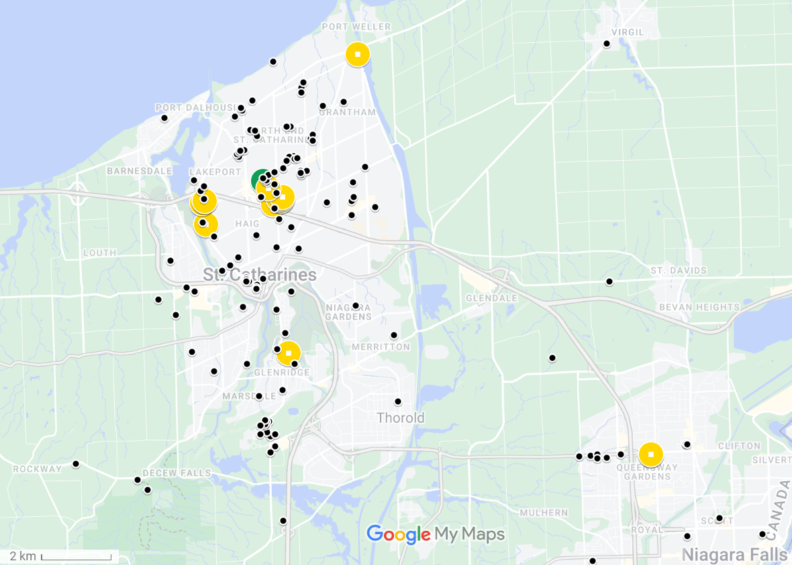

Figure 2: Map of observations from Crowkemon Go and sampling locations.

The black dots represent observations collected from Crowkemon Go, and the circular icons are sampling locations. The single recurrent site used is in green. Opportunistic sampling sites are in yellow. The focal area was limited to the St. Catharines & Niagara region.

heatwave). Upon arriving at the recurrent sampling location, a Nikon D5300 camera with a 70-300mm Nikkor lens was set up on a tripod at a minimum of 15m away from a concrete pad (predetermined bait location). If crows were already foraging in the area, we would begin recording immediately and not bait the site since approaching them would likely cause them to abandon the site. If the crows were not foraging (e.g. perched nearby), an observer approached and visibly dropped 30g of Cheez-Its, then returned to the camera. If crows were on-site, recording would start immediately, whereas if the crows were absent, a crow-caller would be used for 20 minutes (5s. call per minute, 5 mins on, 5 mins off for 20 minutes or until crows appear) to attract them. We began recording when crows arrived and recorded up to a maximum of 20 minutes. The recording was stopped if the crows vacated the area for longer than 5 minutes and we remained in the area for 10 minutes post-departure in case the crows returned. If the crows returned within 5 minutes, we would continue the trial. For opportunistic sampling, we looked for crows using Crowkemon Go as a guide. If we found crows that were already foraging, we would set up in the same manner as for recurrent sampling and did not bait the site. Conversely, if the crows were not already foraging, we would bait the site as we did for recurrent sampling.

The presence of a sentinel, whether heard or seen, was announced verbally by the observer during the recording. For each location, we classified the type of environment using St. Catharines municipal zoning maps, later generalized as either “commercial” or “green” (Table S1**)**. Disturbance frequency was calculated by dividing the number of disturbances by the duration of the recording. We identified disturbances as anything passing within 5m of the crows’ foraging area, including vehicles, pedestrians, and domestic and wild animals. The group size was binned into two categories: small (4) and large (4).

Video Analysis

For video analyses, we used the Behavioral Observation Research Interactive Software (BORIS v.8.9.4) [86]. We classified behaviours as either “foraging” or “alert”. “Alert” behaviour was defined as an upright posture where the individual is scanning their surroundings, and “foraging” was when the individual was looking downward and unable to effectively scan their surroundings while pecking at or looking for food on the ground (Table S2). We recorded the duration of bouts of each behaviour longer than 0.01s. Movement behaviour was recorded, but since not all bouts of movement were recorded in their entirety, “moving” behaviour was excluded from these analyses. We then calculated the proportion of time spent performing each behaviour. An individual could have two observations if sentinel presence changed, as bouts were recorded separately for whether a sentinel was present or not.

We also recorded the number of pecks (handling food with their beaks to eat it) to quantify foraging effort. The peck rate (per minute) was calculated for every individual by dividing the total number of pecks at food performed by the total duration of “foraging” behaviour. The peck rate of individuals who spent no time foraging could not be calculated and were therefore excluded from peck rate analysis.

Statistical Analysis

All statistical analyses were performed in the R environment (v.4.2.2; R Core Team 2022) [87]. We first ran separate chi-squared tests to determine if the generalized environment, the group size, or the disturbance frequency affected the likelihood of sentinel presence. To determine the effects of generalized environment and sentinel presence on the proportion of time allocated to each behaviour (alert or foraging), we used the “lm” function in the R Stats package [87] to fit a linear model using behaviour type, sentinel presence, and generalized environment as predictors.

To determine the effects of generalized environment and the presence of a sentinel on the duration of bouts of all behaviours, we used the function “rlmer” from the “robustlmm” package [88] to fit a robust linear mixed model to the log-transformed duration of bouts with behaviour type, sentinel presence, generalized environment, group size, and bait presence as fixed factors, the disturbance frequency (number of disturbances per min.) as a fixed effect and the individual ID as a random effect. We then fitted post-hoc robust linear mixed models on each behaviour to determine the effects of sentinel presence and generalized environment on each behaviour. The duration of behavioural bouts was log-transformed to normalize the distribution.

To determine the effects of sentinel presence and generalized environment on peck rate, we used the function “rlmer” from the “robustlmm” package [88] to fit a robust linear mixed model to the peck rate of foragers using sentinel presence, generalized environment, group size, and bait presence as fixed factors, the disturbance frequency (per min) as a fixed effect, and the individual ID as a random effect.

Finally, we counted the number of transitions from each behaviour to determine the effects of sentinel presence and generalized environment on the frequency of each transition type. Using the “glmer” function from the “lme4” package [89], we fitted a generalized linear mixed model using a Poisson distribution to the number of occurrences of each transition. Sentinel presence, generalized environment, and bait presence were fixed factors, the disturbance frequency (per min) was used as a fixed effect, and the total number of transitions performed by the individual was used as a random effect in the model.

Post hoc estimated marginal means tests were performed as appropriate using the “emmeans” function from the “emmeans” package [90]. P-values were corrected using the “fdr” method, and the results were averaged over the unused categorical factors.

Results

Sentinel presence

In summer 2022, we recorded 23 videos of crows foraging and made 13 observations in commercial and 20 observations in green areas. Since sentinel presence changed in 8 videos, we made 19 observations with a sentinel present and 14 observations without a sentinel for a total of 33 observations. The generalized environment (χ2 = 0.122, df = 1, p = 0.727; Figure S2), group size (χ2 = 0.248, df = 1, p = 0.618; Figure S3), and the disturbance frequency (χ2 = 2.033, df = 2, p = 0.362; Figure S3) did not significantly affect if a sentinel was present or not in our observations.

Proportion of time allocated to each behaviour

We recorded 64 individuals across 23 videos. Since 17 individuals were recorded in both the presence and absence of a sentinel, we calculated the proportion of time allocated to each behaviour for 81 observations. Crows allocated similar proportions of time to foraging and vigilance ( = 0.026, SE = 0.023, t = 1.160, p = 0.248; Figure 3, Table 4), and neither the presence of a sentinel ( = -0.034, SE = 0.023, t = -1.431, p = 0.154; Figure 3, Table 4) or the generalized environment ( = 0.034, SE = 0.023, t = 1.463, p = 0.146; Figure 3, Table 4) had an effect on the proportion of time allocated to either alert or foraging behaviour.

Figure 3: Proportion of time allocated to each behaviour by foragers in commercial and green areas

Table 4: Effects of sentinel presence and generalized environment on the proportion of time allocated to each behaviour.

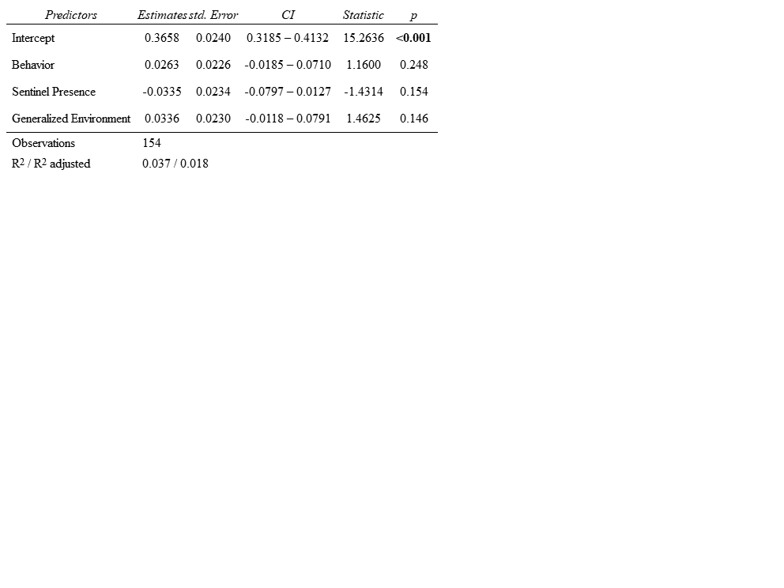

Duration of bouts of all behaviours

In total, 3897 bouts were recorded, of which 2110 bouts were of “alert” behaviour, and 1787 bouts were of “foraging” behaviour. The average duration of bouts was 1.75 seconds. Bouts of alertness and foraging significantly differed ( = -0.256, SE = 0.051, t = -5.002, p = <0.001; Figure 4, Table 5), with bouts of alertness significantly (1.64 seconds) shorter than bouts of foraging (1.88 seconds). Sentinel presence significantly increased the duration of bouts of all behaviours ( = 0.197, SE = 0.072, t = 2.741, p = 0.006; Figure 4, Table 5). Green areas saw significantly longer bouts of all behaviours than commercial areas ( = 0.353, SE = 0.087, t = 4.048, p = <0.001; Figure 4, Table 5). Disturbance frequency had a significant effect on the duration of all bouts ( = -0.088, SE = 0.030, t = -2.975, p = 0.003; Figure S4, Table 5), with bout duration decreasing as disturbance frequency increased. We found a significant interaction between generalized environment and sentinel presence ( = -0.252, SE = 0.088, t = -2.863, p = 0.004; Figure 4, Table 5), and between behaviour type and generalized environment ( = -0.202, SE = 0.054, t = -3.769, p = <0.001; Figure 4, Table 5).

Duration of bouts of “foraging” behaviour

To determine if the generalized environment and sentinel presence affected the duration of bouts of foraging and alert behaviour differently, we fit separate linear mixed models for each type of behaviour bout. Sentinel presence had no significant effect on the duration of bouts of foraging behaviour ( = 0.092, SE = 0.072, t = 1.280, p = 0.201; Figure 4, Table 5). Generalized environment had a significant effect on the duration of bouts of foraging behaviour, with longer bouts in green areas ( = 0.383, SE = 0.078, t = 4.919, p = <0.001; Figure 4, Table 5). Larger groups had significantly longer bouts of foraging behaviour ( = -0.152, SE = 0.068, t = -2.221,

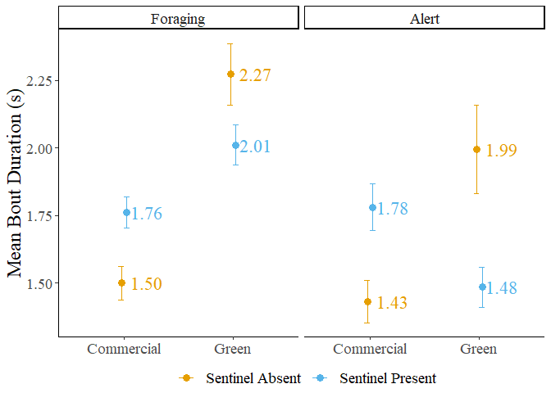

Figure 4: Mean bout duration of foragers in commercial and green areas. The error bars represent the standard error.

Table 5: Results of the linear mixed models fit to the mean bout duration.

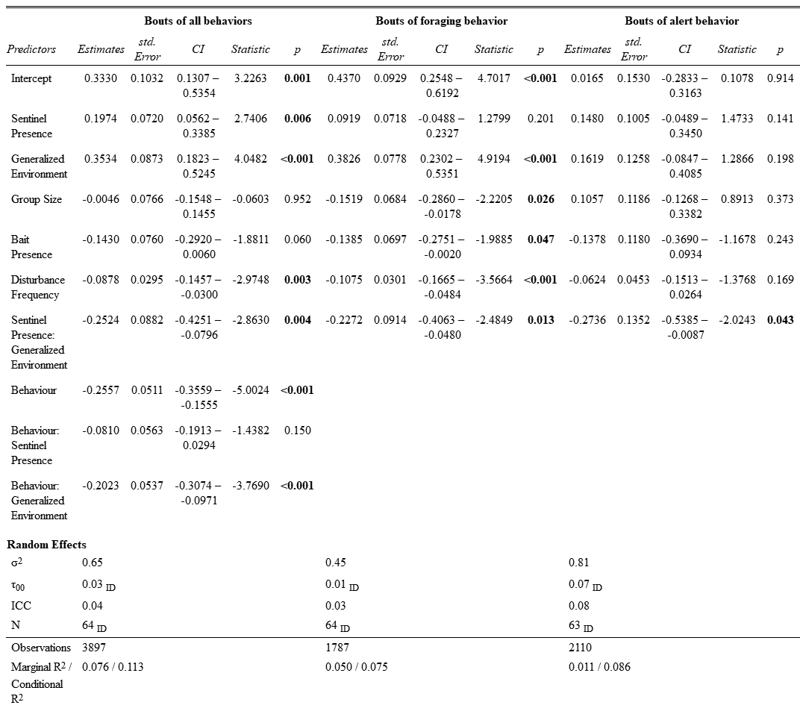

p = 0.026; Figure 5, Table 5). The presence of bait significantly decreased the duration of foraging bouts ( = -0.139, SE = 0.070, t = -1.989, p = 0.047; Figure S5, Table 5). Increasing disturbance frequency significantly decreased the duration of foraging bouts ( = -0.108, SE = 0.030, t = -3.566, p = <0.001; Figure 6, Table 5). We found a significant interaction between generalized environment and sentinel presence ( = -0.227, SE = 0.091, t = -2.485, p = 0.013; Figure 4, Table 5). Post hoc tests revealed significant differences in the duration of bouts of foraging behaviour. In the absence of a sentinel, foragers in green areas had significantly longer bouts of foraging behaviour than in commercial areas ( = -0.383, SE = 0.078, z-ratio = -4.919, p < 0.001; Table S3). In the presence of a sentinel, foragers in green areas also had significantly longer bouts of foraging behaviour than in commercial areas ( = -0.156, SE = 0.067, z-ratio = -2.337, p = 0.029; Table S3). In green areas, foragers in the presence of a sentinel had marginally shorter bouts of foraging behaviour than in the absence of a sentinel ( = 0.135, SE = 0.068, z-ratio = 1.977, p = 0.058; Table S3).

Duration of bouts of “alert” behaviour

Sentinel behaviour, generalized environment, group size, bait presence and disturbance frequency had no significant effect on the duration of bouts of alert behaviour (p < 0.141; Table 5). We found a significant interaction between sentinel behaviour and generalized environment ( = -0.274, SE = 0.135, t = -2.024, p = 0.043; Figure 4, Table 5). Post hoc pairwise t-tests revealed no significant differences in the duration of bouts of alert behaviour.

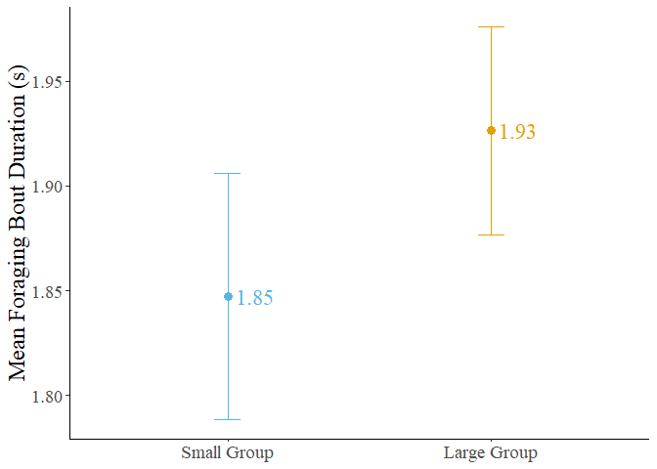

Figure 5: Mean foraging bout duration of crows in small and large groups. Error bars represent the standard error.

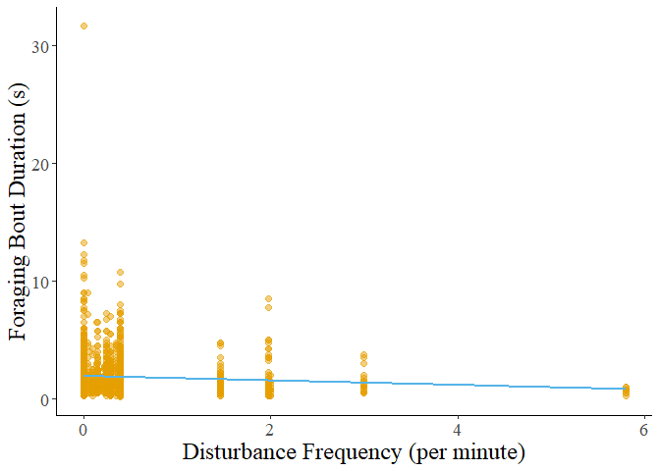

Figure 6: Foraging bout duration decreasing with increasing disturbance frequency.

Foraging rate

We calculated the peck rate (per min.) for 81 observations. Two observations were removed as the individuals did not perform any foraging behaviour. Neither the presence of a sentinel, the generalized environment, nor group size had a significant effect on the peck rate of foragers (p > 0.233; Figure 7, Table 6). The presence of bait significantly increased the peck rate of foragers ( = 13.990, t = 2.231, p = 0.020; Figure S6, Table 6). Peck rate increased significantly with disturbance frequency ( = 5.290, t = 2.312, p = 0.021; Figure 8, Table 6). We found a significant interaction between generalized environment and disturbance frequency ( = 16.150, t = 3.046, p = 0.002; Figure 8, Table 6).

Transition analysis

The number of transitions from foraging to alert behaviour was significantly higher in green areas (IRR = 0.421, SE = 0.157, z = -1.355, p = 0.020; Figure 9, Table 7), and in areas with frequent disturbances (IRR = 0.728, SE = 0.109, z = -2.130, p = 0.033; Figure 10, Table 7). We found a significant interaction between generalized environment and sentinel presence (IRR = 5.021, SE = 2.457, z = 3.298, p = 0.001; Figure 9, Table 7). The number of transitions from foraging to pecking was significantly higher in the presence of bait (IRR = 1.710, SE = 0.384, z = 2.386, p = 0.017; Figure S7, Table 7). Sentinel presence, generalized environment, disturbance frequency, or the interaction between sentinel presence and generalized environment did not affect the number of transitions from foraging to pecking (p-value > 0.385; Table 7). The number of transitions from pecking to alert behaviour was also significantly higher in the presence of bait (IRR = 2.204, SE = 0.538, z = 3.238, p = 0.001; Figure S7, Table 7).

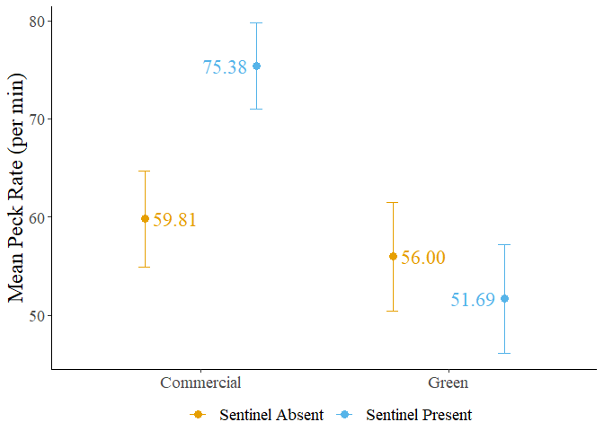

Figure 7: Mean peck rate of foragers in commercial and green areas. Error bars represent the standard error.

Table 6: Result of the linear mixed model fit to peck rate.

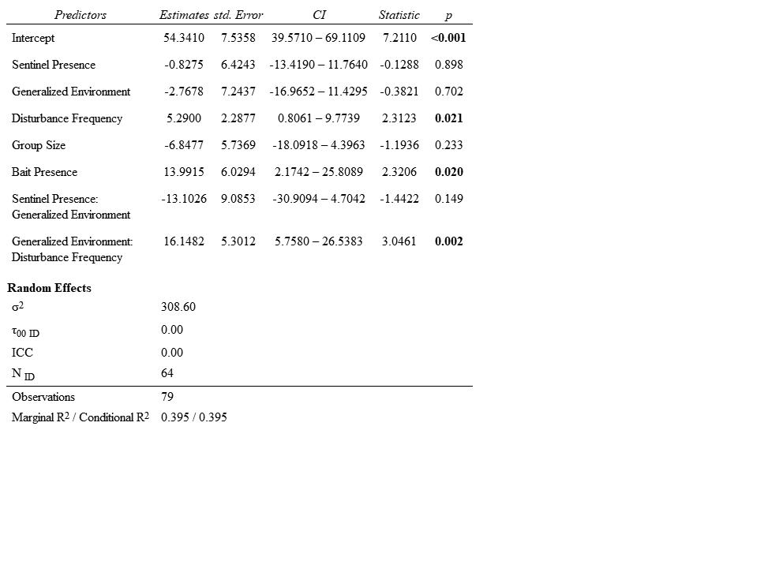

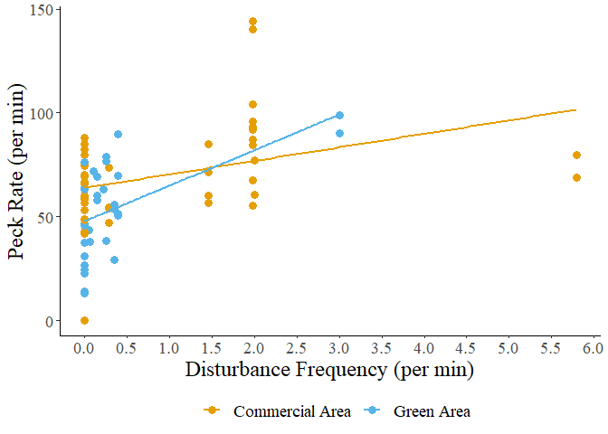

Figure 8: Peck rate in relation to disturbance frequency.

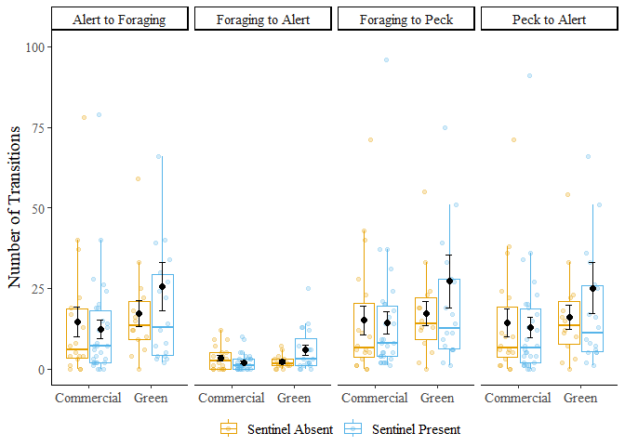

Figure 9: Number of transitions performed by foragers in commercial and green areas. Error bars represent the standard error. Three outliers (Nb.>100) omitted from figure.

Table 7: Results of generalized linear mixed model fit to the number of transitions performed by foragers

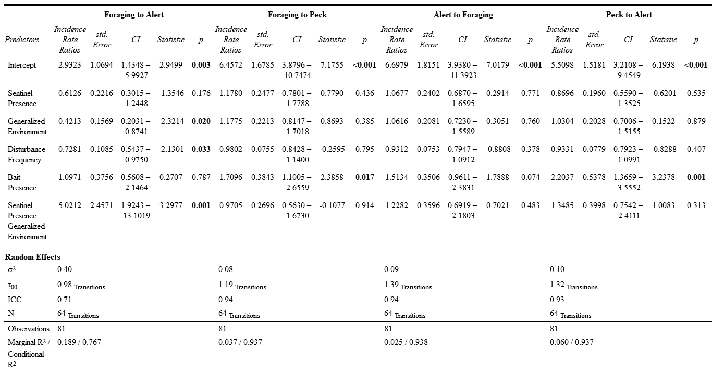

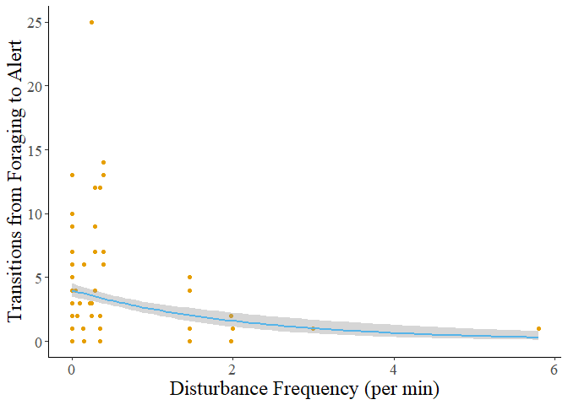

Figure 10: The number of transitions from foraging to alert behaviour decreases as disturbance frequency increases. The grey shadow represents the standard error of the curve.

Sentinel presence, generalized environment, disturbance frequency, or the interaction between sentinel presence and generalized environment did not affect the number of transitions from pecking to alert behaviour (p-value > 0.235; Table 7). The number of transitions from alert to foraging behaviour were not significantly affected by any factors, however, bait presence had a marginally insignificant effect (IRR = 1.513, SE = 0.351, z = 1.789, p = 0.074; Figure S7, Table 7).

Post hoc testing on the number of transitions from foraging to alert behaviour revealed that in green areas, individuals performed more transitions from foraging to alert when in the presence of a sentinel ( = -1.124, SE = 0.346, z-ratio = -3.250, p = 0.007; Table S4). Foragers in the presence of a sentinel performed marginally more transitions from foraging to alert in green areas than in commercial areas ( = -0.749, SE = 0.364, z-ratio = -2.062, p = 0.079; Table S4). However, foragers in the absence of a sentinel performed marginally more transitions from foraging to alert behaviour in commercial areas than in green areas ( = 0.864, SE = 0.372, z-ratio = 2.321, p = 0.061; Table S4).

Discussion

Our study sought to investigate how the presence of a sentinel and the generalized environment affected the behaviour of foraging American crows. We initially hypothesized that the presence of a sentinel would decrease the individual vigilance of crow foragers and that green areas would likewise decrease individual vigilance due to reduced ambient noise and longer lines of sight. We also expected the likelihood of a sentinel presence to increase in commercial and frequently disturbed areas where the benefits of sentinel coverage would be most beneficial to the foragers.

Our results show that sentinel presence had no significant effects on the behaviour of foragers apart from significantly increasing the duration of all behaviours. Moreover, neither the generalized environment, disturbance frequency, nor group size significantly affected the likelihood of a sentinel being present. This unexpected result suggests that sentinel crows could decide to perform sentinel behaviour based more on selfish needs rather than the benefits imparted to the foragers. We found that the generalized environment had a significant effect on forager behaviour, with green areas leading to longer bouts of foraging behaviour and more transitions from the vulnerable to the alert state. This suggests that crows could perceive green areas as less safe, possibly because they need to spend more time being vulnerable. Overall, the study's findings do not fully support the initial hypotheses and suggest that sentinel behaviour and forager behaviour in crows could be influenced by complex interactions between individual factors and forager’s perception of the safety of their environment.

Sentinel behaviour

Our results contrast with previous studies that found that the presence of a sentinel led to a decrease in alert behaviour [39,63]. For example, pied babblers, *Turdoides bicolor*, increased the proportion of time spent foraging after the start of a sentinel bout and had increased biomass intake. Sentinel behaviour can be more selfish, primarily benefiting the sentinel itself rather than being an altruistic strategy benefiting the group at the expense of the sentinel (reference). Bedneckoff's state-dependent model states that individuals make decisions based on their own energetic needs and the benefits they receive [28]. An individual with sufficient energetic reserves could decide to perform sentinel behaviour as a safer option if the alternative is foraging without a sentinel. In urban areas, where high-calorie food patches are bountiful, individuals could be forgoing foraging to act as sentinels for their own safety rather than to provide benefits to the other foraging group members. These sentinels only come down when they are below a critical energetic threshold past which performing sentinel behaviour is unfavourable only to be replaced by another individual with sufficient energetic reserves [28,29].

The benefits of sentinel behaviour can be more subtle or indirect, such as providing a greater sense of security that allows foragers to focus more on foraging without actively reducing their vigilance. The proportion of time allocated to alert behaviour could also be used to scan for foraging patches and other foragers, explaining the absence of effects of sentinel presence on the proportion of time spent being alert. Foragers could also benefit from sentinel presence by increasing the distance between foragers, permitting the group to forage over a greater surface area while compensating for the increased predation risk from foraging further apart [39]. Sentinel behaviour could therefore compensate for riskier group-foraging strategies, not only individual changes in behaviour. The relationship between sentinels and foragers is more complex than it appears, reinforcing the importance of considering individual differences and motivations when studying social behaviours.

Generalized Environment

We found that the generalized environment had significant effects on forager behaviour, particularly in terms of the duration of bouts of foraging behaviour and the number of transitions from the vulnerable to the alert state. In green areas, crows exhibited longer bouts of foraging behaviour, suggesting that they spent more time actively searching for food. Likewise, an increase in the number of transitions from the vulnerable state to the alert state was observed in green areas, suggesting that crows were more vigilant to potential threats, possibly due to the perceived higher predation risk compared to commercial areas.

Green areas, such as parks, offer longer lines of sight and less ambient noise which makes the sentinel more effective [91] but could also benefit urban raptors. Urban red-tailed hawk populations are on the rise and the core of their home ranges is associated with large green areas [79]. Foraging in green areas could therefore be riskier than initially hypothesized, explaining the individual need to maintain vigilance. We observed foraging crows abandon sites when disturbed by raptors but only temporarily flee when disturbed by vehicles. Crows foraging in the street change lanes to avoid oncoming vehicular traffic [92], suggesting that the type of disturbances in each environment could change how risky an environment is to forage on.

The increased duration of foraging bouts in green areas could suggest that they need to spend more time actively searching for and consuming food. We observed shorter bouts of foraging behaviour but a higher peck rate in commercial areas. In green areas, food can be more dispersed, require more time to locate, and could be obscured by vegetation. Comparatively, food scraps and litter in commercial areas are considerably easier to forage when on impermeable surfaces. Moreover, anthropogenic foods have a greater caloric content than non-anthropogenic foods, making them easier to find and more satiating than other food sources, likely playing a role in the shift in their foraging preferences for anthropogenic foods [49,50].

We found a significant interaction between sentinel presence and generalized environment on the behaviour of crow foragers. The number of transitions from a vulnerable to alert state was highest in green areas and in the presence. We found a significant interaction between sentinel presence and generalized environment on the duration of bouts of foraging and alert behaviour. Bouts were longest in green areas and in the absence of a sentinel, and shortest in commercial areas and the absence of a sentinel (Figure 4). Foragers could be using the indirect benefits provided by sentinel behaviour differently based on their individual and group needs. In green areas foragers could be relying more on the sentinel, foraging further apart and not coordinating vigilance with other group members. We observed this as shorter but more numerous bouts of alert behaviour between longer foraging bouts. In contrast, foragers in the absence of a sentinel could be relying more heavily on social foraging behaviour between foragers on the ground, with longer bouts of alert behaviour to increase the likelihood of at least one crow being alert. Whether crows have ground-level coordination of vigilance is an interesting topic for future research.

In commercial areas, crows in the absence of a sentinel could be foraging in an all-or-nothing manner, devoting as little time as possible to each behaviour resulting in shorter bouts of both foraging and alert behaviour, with a duration similar to the duration of bouts of alert behaviour in green areas and in the presence of a sentinel. In comparison, foragers in the presence of a sentinel and in commercial areas saw approximately equal durations of bouts of foraging and alert behaviour. The increased duration of bouts of alert behaviour could be due to the increased frequency and velocity of disturbances, paired with the increased ambient noise, making the sentinel’s behaviour less effective. The duration of bouts of foraging behaviour was likewise increased but not as much as in green spaces, further supporting the hypothesis that foraging in green spaces requires more handling time than in commercial areas. By changing the duration and frequency of bouts to best take advantage of the benefits provided by the sentinel, crows maximize their foraging success and minimize the risk of predation in different foraging environments. American crows continue to demonstrate a behavioural adaptability that is likely crucial for their success in urban cityscapes, and this adaptability must also include the use of social foraging behaviours.

Disturbances

Higher disturbance frequency led to a decrease in the duration of bouts of all behaviours, particularly foraging. American crows decreased their time foraging to minimize their exposure to perceived threats. Areas with higher disturbance frequencies typically had a greater frequency of vehicular disturbances, which American crows could be more tolerant of. As a result and consistent with the risk allocation hypothesis [93], crows can continue to forage between disturbances, but will also increase foraging rate when under high chronic risk of predation. Peck rate did significantly increase with disturbance frequency, and we found a significant interaction between disturbance frequency and generalized environment on peck rate. In response to increasing disturbance frequency, foragers in green areas increased their peck rate more than foragers in commercial areas, further supporting the hypothesis that the type of disturbance as well as the frequency affects the foraging behaviour of urban crows. Higher disturbance frequency was also associated with a significant decrease in the number of transitions from foraging to alert behaviour, from which we can infer that crows will attempt to spend as little time as possible under threat while maximizing time spent foraging. Crows could then be foraging as quickly as possible while maintaining minimal vigilance and flying away as soon as a threat is detected.

Baited sites

The presence of bait, which can be considered a proxy for human-generated litter in the environment, increased the peck rate and decreased the duration of foraging bouts. This suggests that foraging on bait or litter is more efficient and safer for crows, requiring less time and effort compared to foraging on natural food sources. This observation could explain why a shift in preference for anthropogenic foods is observed in American crows and potentially other urbanized species [49,50]. American crows are increasingly found in North American cities and the increasing abundance of crows in cities is believed to be driven by the increased presence of highly caloric anthropogenic foods [49].

Group Size

As group size increased, the duration of bouts of foraging behaviour increased but was not associated with a decrease in the duration of bouts of alert behaviour. The proportion of time allocated to either behaviour was also unchanged by the size of the group. This finding is surprising, as previous studies suggest that larger group sizes should decrease individual vigilance while increasing foraging efficiency [66,94–96], yet the effect of group size was only observed in the duration of bouts of foraging behaviour. Bouts of alert behaviour could have a minimal duration to effectively monitor the surrounding environment for sources of threat. Alternatively, foraging crows could be maintaining vigilance due to increased competition for resources in larger groups. Instead of only looking out for sources of threat, foragers could be looking at the behaviour of other group members in case they found a better patch to forage on.

Future directions and improvements

Our study has several limitations that should be acknowledged. Our sample size could have limited the ability to detect significant effects. As such, caution should be exercised when interpreting the results, and further studies with larger sample sizes are required to make conclusive statements. Future studies should make use of long-term video recorders in areas where crows forage across a wider breadth of urbanization. Additionally, the study focused on the population of crows in St. Catharines Ontario, which could limit the generalizability of our results to other populations or environments. Factors such as local food availability, the number and area of green spaces, and predator presence can vary widely between cities, and these factors can affect the behaviour of murders of foraging crows. Therefore, the findings of our study could differ from those of a similar study performed in a different city, but also within the city. Crows can aggregate in many other areas besides green and commercial areas, and future research could be conducted on the effects of urban microcosms on the social foraging of crows.

Our study investigated the effects of sentinel behaviour and the generalized environment on the behaviour of foraging crows in urban environments. Contrary to expectations, sentinel presence did not have a significant effect on forager behaviour. This suggests that sentinel decision-making could be more influenced by individual needs rather than group benefits, aligning with Bednekoff's state-dependent model. The generalized environment, however, had a significant impact on forager behaviour. Crows in green areas exhibited longer bouts of foraging behaviour and more transitions from the vulnerable to the alert state compared to those in commercial areas. This indicates that environmental factors such as resource distribution and predation risk play a crucial role in shaping forager behaviour. Disturbance frequency, bait presence, and group size also influenced forager behaviour. Higher disturbance frequency led to shorter bouts of behaviour but increased peck rate, indicating a trade-off between vigilance and foraging efficiency. Bait presence increased peck rate and decreased foraging time, suggesting that foraging on anthropogenic food sources could be more effective for crows.

These findings have several implications for understanding crow behaviour. They suggest that crows can adapt their behaviour based on environmental conditions and individual needs. The lack of significant effects of sentinel behaviour points towards the complexity of social behaviour in crows and the importance of considering individual variation in decision-making. Overall, the study provides valuable insights into the factors influencing crow behaviour in urban environments and highlights the need for further research to fully understand these complex behaviours.

Chapter 4. General Discussion

Thesis summary

The objectives of my thesis were to investigate how sentinel behaviour could change in chapter 2, and then observe changes in behaviour in an urban sentinel species, the American crow, in chapter 3. The purpose of our research was to better understand how an environmental factor like urbanization could influence social behaviour. Sentinel behaviour, where individuals take watch over other group members, is an essential tool for the reduction of predation risk. The behaviour could be even more useful in human-altered environments where wildlife must navigate novel challenges and adapt to their surroundings. By observing changes in social behaviours and understanding the underlying mechanisms behind behavioural decisions, we could gain a better understanding of how these behaviours have evolved, and how they could continue to evolve in the future.

Our scoping review identified several intrinsic and extrinsic factors that can influence sentinel behaviour across several different species. Intrinsic factors such as sex, maturity, body mass, and satiation were found to affect the likelihood of performing sentinel behaviour. Males generally performed more sentinel behaviour than females, possibly due to differences in energetic investment between the sexes. Older and more experienced individuals also tended to sentinel more than younger individuals, likely because of their greater experience with threats making them more effective sentinels. Satiation and body mass were also found to influence sentinel behaviour, with heavier and more satiated individuals more likely to sentinel. The effects of intrinsic factors can be explained through the state-dependent model for sentinel behaviour, where the core motivators are the energetic reserves and the need for safety.

Extrinsic factors such as dominance, group size, and risk also played significant roles in shaping sentinel behaviour. Dominant individuals, usually males, were observed to sentinel more than subordinates, possibly due to their greater access to resources and additional benefits received from sentinel behaviour. Group size predictably influenced sentinel behaviour, with larger groups showing decreased individual sentinel behaviour but increased group-level sentinel behaviour. Increased risk, whether from predators, outgroup rivals, or the presence of pups, also led to increased sentinel behaviour. Overall, the review highlighted the complex interplay of intrinsic and extrinsic factors in shaping sentinel behaviour across species.

The factors identified in the scoping review generally aligned with the findings of chapter 3. There were no differences in the presence of a sentinel caused by generalized environment suggesting that environmental and energetic factors were equal throughout the different environments within an urban area. Additional studies on the behaviour of sentinel crows would be needed to verify that claim. The absence of effects of disturbance frequency and group size were surprising and could be due to differences in the types of disturbances, and increased availability of food in urban settings.

Our empirical study focused on investigating how the presence of a sentinel and the generalized environment affected the behaviour of foraging American crows. Unexpectedly, we found that sentinel presence had very few significant effects on forager behaviour, apart from significantly increasing the duration of all behaviours. This was contrary to our initial hypothesis, that the presence of a sentinel would decrease individual vigilance in foragers. It is possible that sentinel coverage had more subtle effects on foraging behaviours, potentially allowing group members to forage over a wider area without suffering an increased risk of predation. In contrast, the generalized environment had a significant effect on forager behaviour. Crows in green areas exhibited longer bouts of foraging behaviour and more transitions from the vulnerable to the alert state compared to those in commercial areas. This could be because green areas are perceived as less safe, possibly because they need to spend more time being vulnerable looking for food, or the presence of urban predators like the red-tailed hawk. The significant interactions between the effects of generalized environments and sentinel presence sheds light on how adaptable American crow behaviours can be and highlights their ability to succeed in urban environments.

The foraging environment could therefore influence sentinel behaviour in both the sentinel but also the response of foragers to the sentinel. Drawing from both the scoping review and the empirical study on American crows, we can infer the key effects of the generalized environment on sentinel behaviour. The availability and distribution of food resources can impact the need for sentinels. Litter, usually a highly concentrated patch of food, can be easier to locate and take less time to forage on than critters dwelling in tall grasses. Foraging in green spaces where vegetation obscures food, therefore, takes more time to find food, increasing the duration of time foragers spend vulnerable. This increased risk can result in individuals choosing to sentinel more often, though this was not observed in our study. Anthropogenic foods found throughout urban areas are also more calorically dense than more natural foods, potentially increasing the energetic reserves of individuals, and allowing urban individuals to sentinel more than their rural counterparts.

The frequency and types of disturbances could also alter the need to rely on sentinels. In commercial areas, foragers could encounter more vehicular disturbances than in green areas where the odds of encountering a raptor are higher. The latter disturbance could trigger a more urgent antipredator response than the former, to which crows could be much more tolerant towards despite the increased frequency of encounters. High-risk microenvironments in urban areas could lead to increased sentinel behaviour as individuals prioritize vigilance to reduce the risk of predation. In contrast, lower predation risk environments like commercial areas could result in a reduced need for sentinel behaviour as individuals feel safer and allocate more time to foraging.

Truly understanding the decision-making underpinning sentinel behaviour requires a holistic approach that considers a very wide range of individual and environmental factors. Determining how these factors interact and play a role in shaping the trade-offs associated with sentinel behaviour should be of particular interest to future studies. Furthermore, studying sentinel behaviour in urbanized species such as the American crow can provide unique insights into how animals perceive and respond to human-altered landscapes and can lead to a better understanding of how sentinel behaviour contributes to the success of these species.

Despite the insights gained from our empirical study, we should acknowledge some of the limitations of the empirical study. One limitation is the relatively small sample size of crows observed, which may have limited the statistical power of our analyses. A larger sample size would have allowed a better examination of the factors influencing forager and sentinel behaviour. Collecting observations from a wider diversity of microenvironments could also help reveal more subtle environmental effects at play. Our study was conducted in St. Catharines, Ontario which is known for having a higher-than-average presence of green areas. This could limit the generalizability of our findings to other populations of crows in different cities with fewer green spaces. Factors such as local food availability, predator presence, and the distribution of green spaces can also vary widely between cities. Therefore, caution should be exercised when extrapolating our results to other populations or environments.

Future Studies

Future studies could improve on our findings by sampling over a greater breadth of urbanization, providing a larger sample size to increase the statistical power of their analyses. Additionally, researchers could consider conducting a long-term study to observe sentinel behaviour and forager responses over an extended period. This could allow the identification of temporal effects on the behaviour. Future studies could also sample populations from different cities to help improve the generalizability of our findings. The discovery of geographic differences in sentinel behaviour would be interesting and analysis of the causes of such differences could be fruitful in furthering our understanding of how social behaviours change in urban settings. A repeat study could look at the indirect effects of sentinel presence on foraging strategies could confirm the hypotheses proposed for the lack of effect of sentinel presence on forager behaviour. A more comprehensive evaluation of foraging environments, for example by measuring ambient noise during foraging events, could help reveal environmental factors we did not look at.

Implications

The findings of the scoping review and empirical study have several implications, particularly regarding the management of urban wildlife populations. By understanding the factors that influence social behaviours, conservationists and urban planners can develop more effective identify stressors in the environment and develop strategies to mitigate the negative impacts of urbanization on wildlife. Furthermore, an improvement in the knowledge of the effects of urbanization on social behaviour illuminates the mechanisms responsible for the evolution of the behaviour and how it could evolve in the future. Research on how social behaviours contribute to the success of species in urban environments could allow conservationists to improve conservation efforts by facilitating these behaviours in species at risk. Disrupting the social behaviours of urbanized species could lead to less harmful management techniques aimed at reducing their success.

Concluding statements

The main findings from the scoping review and empirical study shed light on the factors influencing sentinel behaviour in urban environments, particularly in American crows. The scoping review identified a range of intrinsic and extrinsic factors that can affect sentinel behaviour, including group size, predation risk, and resource distribution. However, the empirical study found that sentinel presence did not have a significant effect on forager behaviour in American crows, suggesting that the effects of sentinel presence in urban areas can be more subtle than initially predicted.

The findings of this thesis can have several implications for understanding sentinel behaviour and its effect on forager behaviour. Our scoping review’s findings suggest that sentinel behaviour decision-making is complex and revolves around individual motivators such as energetic reserves and requirements for safety. The findings of our empirical study reinforce the importance of considering environmental factors affecting the behaviour of urban social species. While our study provides valuable insights, it also raises new questions and challenges that warrant further investigation and reemphasizes the need for further research to explore the effects of urbanization on the social behaviour of urban species, and its contribution to the success of these species.

The findings of the scoping review and empirical study have several implications, particularly regarding the management of urban wildlife populations. By understanding the factors that influence social behaviours, conservationists and urban planners can develop more effective identify stressors in the environment and develop strategies to mitigate the negative impacts of urbanization on wildlife. Furthermore, an improvement in the knowledge of the effects of urbanization on social behaviour illuminates the mechanisms responsible for the evolution of the behaviour and how it could evolve in the future. Research on how social behaviours contribute to the success of species in urban environments could allow conservationists to improve conservation efforts by facilitating these behaviours in species at risk. Disrupting the social behaviours of urbanized species could lead to less harmful management techniques aimed at reducing their success. Overall, our results contribute to the growing literature on the effects of urbanization on the behaviour of animals.

References

1. Bednekoff PA. 2015 Sentinel behavior: a review and prospectus. In *Advances in the Study of Behavior*, pp. 115–145. Elsevier. (doi:10.1016/bs.asb.2015.02.001)

2. Blumstein DT. 1999 Selfish sentinels. *Science* **284**, 1633–1634. (doi:10.1126/science.284.5420.1633)

3. Huels FD, Stoeger AS. 2022 Sentinel behavior in captive meerkats ( *Suricata suricatta* ). *Zoo Biol.* **41**, 10–19. (doi:10.1002/zoo.21644)

4. Rauber R, Manser MB. 2021 Effect of group size and experience on the ontogeny of sentinel calling behaviour in meerkats. *Anim. Behav.* **171**, 129–138. (doi:10.1016/j.anbehav.2020.11.014)

5. Rauber R, Clutton-Brock TH, Manser MB. 2019 Drought decreases cooperative sentinel behavior and affects vocal coordination in meerkats. *Behav. Ecol.* **30**, 1558–1566. (doi:10.1093/beheco/arz112)

6. Santema P, Clutton-Brock T. 2013 Meerkat helpers increase sentinel behaviour and bipedal vigilance in the presence of pups. *Anim. Behav.* **85**, 655–661. (doi:10.1016/j.anbehav.2012.12.029)

7. Santema P, Teitel Z, Manser M, Bennett N, Clutton-Brock T. 2013 Effects of cortisol administration on cooperative behavior in meerkat helpers. *Behav. Ecol.* **24**, 1122–1127. (doi:10.1093/beheco/art039)

8. Manser M. 2018 Meerkats – identifying cognitive mechanisms underlying meerkat coordination and communication: experimental designs in their natural habitat. In *Field and Laboratory Methods in Animal Cognition* (eds N Bueno-Guerra, F Amici), pp. 286–307. Cambridge University Press. (doi:10.1017/9781108333191.015)

9. Eastcott E, Kern JM, Morris-Drake A, Radford AN. 2020 Intrapopulation variation in the behavioral responses of dwarf mongooses to anthropogenic noise. *Behav. Ecol.* **31**, 680–691. (doi:10.1093/beheco/araa011)

10. Kern JM, Radford AN. 2018 Experimental evidence for delayed contingent cooperation among wild dwarf mongooses. *Proc. Natl. Acad. Sci.* **115**, 6255–6260. (doi:10.1073/pnas.1801000115)

11. Kern JM, Radford AN. 2014 Sentinel dwarf mongooses, *Helogale parvula*, exhibit flexible decision making in relation to predation risk. *Anim. Behav.* **98**, 185–192. (doi:10.1016/j.anbehav.2014.10.012)

12. Kern JM, Radford AN. 2013 Call of duty? Variation in use of the watchman’s song by sentinel dwarf mongooses, *Helogale parvula*. *Anim. Behav.* **85**, 967–975. (doi:10.1016/j.anbehav.2013.02.020)

13. Horrocks JA, Hunte W. 1986 Sentinel behaviour in vervet monkeys: who sees whom first? *Anim. Behav.* **34**, 1566–1568. (doi:10.1016/S0003-3472(86)80226-3)

14. Bolwig N. 1959 A study of the behaviour of the chacma baboon, *Papio ursinus*. *Behaviour* **14**, 136–162. (doi:10.1163/156853959X00054)

15. Bednekoff PA, Woolfenden GE. 2003 Florida scrub-jays ( *Aphelocoma coerulescens* ) are sentinels more when well-fed (even with no kin nearby): sentinel behavior by Florida scrub-jays fed peanuts. *Ethology* **109**, 895–903. (doi:10.1046/j.0179-1613.2003.00926.x)

16. Hailman JP, McGowan KJ, Woolfenden GE. 2010 Role of helpers in the sentinel behaviour of the Florida scrub jay (*Aphelocoma c. coerulescens*). *Ethology* **97**, 119–140. (doi:10.1111/j.1439-0310.1994.tb01034.x)

17. Bednekoff PA, Woolfenden GE. 2006 Florida scrub-jays compensate for the sentinel behavior of flockmates. *Ethology* **112**, 796–800. (doi:10.1111/j.1439-0310.2006.01227.x)

18. Fleischer AL, Bowman R, Woolfenden GE. 2003 Variation in foraging behavior, diet, and time of breeding of Florida scrub-jays in suburban and wildland habitats. *The Condor* **105**, 515–527. (doi:10.1093/condor/105.3.515)

19. McGowan KJ, Woolfenden GE. 1989 A sentinel system in the Florida scrub jay. *Anim. Behav.* **37**, 1000–1006. (doi:10.1016/0003-3472(89)90144-9)

20. Edelaar P, Wright J. 2006 Potential prey make excellent ornithologists: adaptive, flexible responses towards avian predation threat by Arabian babblers *Turdoides squamiceps* living at a migratory hotspot: predation threat flexibility in babblers. *Ibis* **148**, 664–671. (doi:10.1111/j.1474-919X.2006.00567.x)

21. Ostreiher R, Heifetz A. 2017 The sentinel behaviour of Arabian babbler floaters. *R. Soc. Open Sci.* **4**, 160738. (doi:10.1098/rsos.160738)

22. Ostreiher R, Heifetz A. 2019 The sentineling-foraging trade-off in dominant and subordinate arabian babblers. *Ethology* **125**, 98–105. (doi:10.1111/eth.12833)

23. Ostreiher R, Mundry R, Heifetz A. 2021 On the self-regulation of sentinel activity among Arabian babbler groupmates. *Anim. Behav.* **173**, 81–92. (doi:10.1016/j.anbehav.2021.01.002)

24. Wright J, Berg E, De Kort SR, Khazin V, Maklakov AA. 2001 Cooperative sentinel behaviour in the Arabian babbler. *Anim. Behav.* **62**, 973–979. (doi:10.1006/anbe.2001.1838)

25. Wright J, Maklakov AA, Khazin V. 2001 State-dependent sentinels: an experimental study in the Arabian babbler. *Proc. R. Soc. Lond. B Biol. Sci.* **268**, 821–826. (doi:10.1098/rspb.2000.1574)

26. Gaston AJ. 1977 Social behaviour within groups of jungle babblers (*Turdoides striatus*). *Anim. Behav.* **25**, 828–848.

27. Rafay M, Ahmad G, Ruby T, Abdullah M, Rasheed F, Abid M. 2020 Breeding and feeding behaviour of jungle babbler(*Turdiodes striata dumont*, 1923) in agro-ecological zones of district layyah, pakistan. *Pak. J. Zool.* **52**, 1701–1708. (doi:https://dx.doi.org/10.17582/journal.pjz/20170420070416)

28. Bednekoff PA. 1997 Mutualism among safe, selfish sentinels: a dynamic game. *Am. Nat.* **150**, 373–392. (doi:10.1086/286070)

29. Bednekoff PA. 2001 Coordination of safe, selfish sentinels based on mutual benefits. *Ann. Zool. Fenn.* **38**, 5–14.

30. Wright J, Berg E, De Kort SR, Khazin V, Maklakov AA. 2001 Safe selfish sentinels in a cooperative bird: *Safe selfish sentinels*. *J. Anim. Ecol.* **70**, 1070–1079. (doi:10.1046/j.0021-8790.2001.00565.x)

31. Olson RS, Haley PB, Dyer FC, Adami C. 2015 Exploring the evolution of a trade-off between vigilance and foraging in group-living organisms. *R. Soc. Open Sci.* **2**, 150135. (doi:10.1098/rsos.150135)

32. Lima SL, Dill LM. 1990 Behavioral decisions made under the risk of predation: a review and prospectus. *Can. J. Zool.* **68**, 619–640. (doi:10.1139/z90-092)

33. Lima SL. 1998 Stress and decision making under the risk of predation: recent developments from behavioral, reproductive, and ecological perspectives. In *Advances in the Study of Behavior* (eds AP Møller, M Milinski, PJB Slater), pp. 215–290. Academic Press. (doi:10.1016/S0065-3454(08)60366-6)

34. Trivers RL. 1971 The Evolution of Reciprocal Altruism. *Q. Rev. Biol.* **46**, 35–57.

35. Hamilton WD. 1964 The genetical evolution of social behaviour. I. *J. Theor. Biol.* **7**, 1–16. (doi:10.1016/0022-5193(64)90038-4)

36. Clutton-Brock TH, O’Riain MJ, Brotherton PNM, Gaynor D, Kansky R, Griffin AS, Manser M. 1999 Selfish sentinels in cooperative mammals. *Science* **284**, 1640–1644. (doi:10.1126/science.284.5420.1640)

37. Morris-Drake A, Christensen C, Kern JM, Radford AN. 2019 Experimental field evidence that out-group threats influence within-group behavior. *Behav. Ecol.* **30**, 1425–1435. (doi:10.1093/beheco/arz095)

38. Walker L, York J, Young A. 2016 Sexually selected sentinels? Evidence of a role for intrasexual competition in sentinel behavior. *Behav. Ecol.* **27**, 1461–1470. (doi:10.1093/beheco/arw064)

39. Hollén LI, Bell MBV, Radford AN. 2008 Cooperative sentinel calling? Foragers gain increased biomass intake. *Curr. Biol.* **18**, 576–579. (doi:10.1016/j.cub.2008.02.078)

40. UN Department of Economic and Social Affairs. 2018 68% of the world population projected to live in urban areas by 2050, says UN. *U. N.* See https://www.un.org/development/desa/en/news/population/2018-revision-of-world-urbanization-prospects.html.

41. Isaksson C. 2018 Impact of urbanization on birds. In *Bird Species: How They Arise, Modify and Vanish* (ed DT Tietze), pp. 235–257. Cham: Springer International Publishing. (doi:10.1007/978-3-319-91689-7_13)

42. Marzluff JM. 2001 Worldwide urbanization and its effects on birds. In *Avian Ecology and Conservation in an Urbanizing World* (eds JM Marzluff, R Bowman, R Donnelly), pp. 19–47. Boston, MA: Springer US. (doi:10.1007/978-1-4615-1531-9_2)

43. Aronson MFJ *et al.* 2014 A global analysis of the impacts of urbanization on bird and plant diversity reveals key anthropogenic drivers. *Proc. R. Soc. B Biol. Sci.* **281**, 20133330. (doi:10.1098/rspb.2013.3330)

44. Ducatez S, Sayol F, Sol D, Lefebvre L. 2018 Are urban vertebrates city specialists, artificial habitat exploiters, or environmental generalists? *Integr. Comp. Biol.* **58**, 929–938. (doi:10.1093/icb/icy101)

45. Callaghan CT, Major RE, Wilshire JH, Martin JM, Kingsford RT, Cornwell WK. 2019 Generalists are the most urban-tolerant of birds: a phylogenetically controlled analysis of ecological and life history traits using a novel continuous measure of bird responses to urbanization. *Oikos* **128**, 845–858. (doi:10.1111/oik.06158)

46. Meillère A, Brischoux F, Parenteau C, Angelier F. 2015 Influence of urbanization on body size, condition, and physiology in an urban exploiter: a multi-component approach. *PLOS ONE* **10**, e0135685. (doi:10.1371/journal.pone.0135685)

47. Lowry H, Lill A, Wong BBM. 2013 Behavioural responses of wildlife to urban environments. *Biol. Rev. Camb. Philos. Soc.* **88**, 537–549. (doi:10.1111/brv.12012)

48. Francis RA, Chadwick MA. 2012 What makes a species synurbic? *Appl. Geogr.* **32**, 514–521. (doi:10.1016/j.apgeog.2011.06.013)

49. Marzluff JM, McGowan KJ, Donnelly R, Knight RL. 2001 Causes and consequences of expanding American Crow populations. In *Avian Ecology and Conservation in an Urbanizing World* (eds JM Marzluff, R Bowman, R Donnelly), pp. 331–363. Boston, MA: Springer US. (doi:10.1007/978-1-4615-1531-9_16)

50. Marzluff JM, Neatherlin E. 2006 Corvid response to human settlements and campgrounds: Causes, consequences, and challenges for conservation. *Biol. Conserv.* **130**, 301–314. (doi:10.1016/j.biocon.2005.12.026)

51. Withey JC, Marzluff JM. 2009 Multi-scale use of lands providing anthropogenic resources by American Crows in an urbanizing landscape. *Landsc. Ecol.* **24**, 281–293. (doi:10.1007/s10980-008-9305-9)

52. Withey J, Marzluff J. 2005 Dispersal by juvenile American crows influences population dynamics across a gradient of urbanization. *The Auk* **122**, 205–221. (doi:10.1093/auk/122.1.205)

53. De León LF, Sharpe DMT, Gotanda KM, Raeymaekers JAM, Chaves JA, Hendry AP, Podos J. 2019 Urbanization erodes niche segregation in Darwin’s finches. *Evol. Appl.* **12**, 1329–1343. (doi:10.1111/eva.12721)

54. Gotanda KM. 2020 Human influences on antipredator behaviour in Darwin’s finches. *J. Anim. Ecol.* **89**, 614–622. (doi:10.1111/1365-2656.13127)

55. Kern JM, Radford AN. 2016 Anthropogenic noise disrupts use of vocal information about predation risk. *Environ. Pollut. Barking Essex 1987* **218**, 988–995. (doi:10.1016/j.envpol.2016.08.049)

56. Stofberg M, Cunningham S, Sumasgutner P, Amar A. 2019 Juggling a “junk-food” diet: responses of an urban bird to fluctuating anthropogenic-food availability. *Urban Ecosyst.* **22**, 1019–1026. (doi:https://doi.org/10.1007/s11252-019-00885-3)

57. Schulte-Hostedde AI, Mazal Z, Jardine CM, Gagnon J. 2018 Enhanced access to anthropogenic food waste is related to hyperglycemia in raccoons (*Procyon lotor*). *Conserv. Physiol.* **6**.

58. Maccarone AD. 1987 Sentinel behaviour in American crows. *Bird Behav.* **7**, 93–95. (doi:10.3727/015613887791918105)

59. Arbon JJ, Kern JM, Morris-Drake A, Radford AN. 2020 Context-dependent contributions to sentinel behaviour: audience, satiation and danger effects. *Anim. Behav.* **165**, 143–152. (doi:10.1016/j.anbehav.2020.04.021)

60. Łopucki R, Klich D, Kiersztyn A. 2021 Changes in the social behavior of urban animals: more aggression or tolerance? *Mamm. Biol.* **101**, 1–10. (doi:10.1007/s42991-020-00075-1)

61. Ridley AR, Raihani NJ, Bell MBV. 2010 Experimental evidence that sentinel behaviour is affected by risk. *Biol. Lett.* **6**, 445–448. (doi:10.1098/rsbl.2010.0023)

62. Haddaway NR, Macura B, Whaley P, Pullin AS. 2018 ROSES RepOrting standards for Systematic Evidence Syntheses: pro forma, flow-diagram and descriptive summary of the plan and conduct of environmental systematic reviews and systematic maps. *Environ. Evid.* **7**, 7. (doi:10.1186/s13750-018-0121-7)

63. Ridley AR, Wiley EM, Thompson AM. 2014 The ecological benefits of interceptive eavesdropping. *Funct. Ecol.* **28**, 197–205. (doi:10.1111/1365-2435.12153)

64. Kung JY. 2023 Elicit. *J. Can. Health Libr. Assoc.* **44**, 15–18. (doi:10.29173/jchla29657)

65. Lajeunesse MJ. 2015 Facilitating systematic reviews, data extraction and meta‐analysis with the metagear package for r. *Methods Ecol. Evol.* **7**, 323–330. (doi:https://doi.org/10.1111/2041-210X.12472)

66. Lima SL. 1995 Back to the basics of anti-predatory vigilance: the group-size effect. *Anim. Behav.* **49**, 11–20. (doi:10.1016/0003-3472(95)80149-9)

67. Yasukawa K, Whittenberger LK, Nielsen TA. 1992 Anti-predator vigilance in the red-winged blackbird, *Agelaius phoeniceus* : do males act as sentinels? *Anim. Behav.* **43**, 961–969. (doi:10.1016/S0003-3472(06)80009-6)

68. Burton N, Yasukawa K. 2001 The ‘Predator Early Warning System’ of Red-Winged Blackbirds (Sistema de Alarma Temprana Contra Depredadores por Parte de *Agelaius phoeniceus*). *J. Field Ornithol.* **72**, 106–112.

69. Burt DB. 1996 Habitat-use patterns in cooperative and non-cooperative breeding birds: testing predictions with western scrub-jays. *Wilson Bull.* **108**, 712–727.

70. Mainwaring MC, Griffith SC. 2013 Looking after your partner: sentinel behaviour in a socially monogamous bird. *PeerJ* **1**, e83. (doi:10.7717/peerj.83)

71. Zacharias VJ, Mathew DN. 1998 Behaviour of the whiteheaded babbler *Turdoides affinis Jerdon* . **95**, 8.

72. Yasukawa K, Cockburn A. 2009 Antipredator Vigilance in Cooperatively Breeding Superb Fairy-Wrens (*Malurus Cyaneus* ). *The Auk* **126**, 147–154. (doi:10.1525/auk.2009.08074)

73. Houslay TM, Nielsen JF, Clutton‐Brock TH. 2021 Contributions of genetic and nongenetic sources to variation in cooperative behavior in a cooperative mammal. *Evolution* **75**, 3071–3086. (doi:10.1111/evo.14383)

74. Kong D, Møller AP, Zhang Y. 2021 Disturbance and predation risk influence vigilance synchrony of black‐necked cranes *Grus nigricollis* , but not as strongly as expected. *Ecol. Evol.* **11**, 2289–2298. (doi:10.1002/ece3.7196)

75. Sorato E, Gullett PR, Griffith SC, Russell AF. 2012 Effects of predation risk on foraging behaviour and group size: adaptations in a social cooperative species. *Anim. Behav.* **84**, 823–834. (doi:10.1016/j.anbehav.2012.07.003)

76. Goodale E, Beauchamp G, Ruxton GD. 2017 Leadership and Sentinel Behavior. In *Mixed-Species Groups of Animals*, pp. 125–145. Elsevier. (doi:10.1016/B978-0-12-805355-3.00007-5)

77. Gallo T, Fidino M, Lehrer EW, Magle S, Loison A. 2019 Urbanization alters predator‐avoidance behaviours. *J. Anim. Ecol.* **88**, 793–803. (doi:10.1111/1365-2656.12967)

78. Renthlei Z, Borah BK, Trivedi AK. 2017 Effect of urbanization on daily behavior and seasonal functions in vertebrates. *Biol. Rhythm Res.* **48**, 789–804. (doi:10.1080/09291016.2017.1345462)

79. Morrison JL, Gottlieb IGW, Pias KE. 2016 Spatial distribution and the value of green spaces for urban red-tailed hawks. *Urban Ecosyst.* **19**, 1373–1388. (doi:10.1007/s11252-016-0554-0)

80. Latta SC, Latta KN. 2015 Do urban american crows (*Corvus brachyrhynchos*) contribute to population declines of the common nighthawk (*Chordeiles minor*)? *Wilson J. Ornithol.* **127**, 528–533. (doi:10.1676/14-181.1)

81. Rosenberg KV *et al.* 2019 Decline of the North American avifauna. *Science* **366**, 120–124. (doi:10.1126/science.aaw1313)

82. Johnson R. 1994 AMERICAN CROWS. *Handb. Prev. Control Wildl. Damage*

83. Auman HJ, Meathrel CE, Richardson A. 2008 Supersize Me: Does Anthropogenic Food Change the Body Condition of Silver Gulls? A Comparison Between Urbanized and Remote, Non-urbanized Areas. In *Waterbirds*, pp. 122–126. (doi:10.1675/1524-4695(2008)31[122:SMDAFC]2.0.CO;2)

84. Jones TB, Evans JC, Morand-Ferron J. 2019 Urbanization and the temporal patterns of social networks and group foraging behaviors. *Ecol. Evol.* **9**, 4589–4602. (doi:10.1002/ece3.5060)

85. Møller AP. 1990 Changes in the size of avian breeding territories in relation to the nesting cycle. *Anim. Behav.* **40**, 1070–1079. (doi:10.1016/S0003-3472(05)80173-3)

86. Friard O, Gamba M. 2016 BORIS: a free, versatile open-source event-logging software for video/audio coding and live observations. *Methods Ecol. Evol.* **7**, 1325–1330. (doi:10.1111/2041-210X.12584)

87. R Core Team. 2022 R: the R project for statistical computing.

88. Koller M. 2016 Robustlmm: an R package for robust estimation of linear mixed-effects models. *J. Stat. Softw.* **75**, 1–24. (doi:10.18637/jss.v075.i06)

89. Bates D, Mächler M, Bolker B, Walker S. 2015 Fitting linear mixed-effects models using lme4. *J. Stat. Softw.* **67**, 1–48. (doi:10.18637/jss.v067.i01)

90. Lenth RW. 2023 Emmeans: estimated marginal means, aka least-squares means.

91. Hollén LI, Bell MBV, Wade HM, Rose R, Russell A, Niven F, Ridley AR, Radford AN. 2011 Ecological conditions influence sentinel decisions. *Anim. Behav.* **82**, 1435–1441. (doi:10.1016/j.anbehav.2011.09.028)

92. Mukherjee S, Ray-Mukherjee J, Sarabia R. 2013 Behaviour of American Crows (Corvus brachyrhynchos) when encountering an oncoming vehicle. *Can. Field-Nat.* **127**, 229. (doi:10.22621/cfn.v127i3.1488)

93. Lima SL, Bednekoff PA. 1999 Temporal Variation in Danger Drives Antipredator Behavior: The Predation Risk Allocation Hypothesis. *Am. Nat.* **153**, 649–659. (doi:10.1086/303202)

94. Beauchamp G. 2013 *Social predation: how group living benefits predators and prey*. Elsevier.

95. Beauchamp G. 2008 What is the magnitude of the group-size effect on vigilance? *Behav. Ecol.* **19**, 1361–1368. (doi:10.1093/beheco/arn096)

96. Ward C, Low BS. 1997 Predictors of Vigilance for American Crows Foraging in an Urban Environment. *Wilson Bull.* **109**, 481–489.

Supplemental Material

List of Supplemental Tables

Table S1: Explanation of generalized environment. 83

Table S2: Ethogram of behaviours analyzed during foraging events. 84

Table S3: Results of post hoc tests on foraging bout duration. 88

Table S4: Result of post hoc test performed on the number of transitions from foraging to alert behaviour. 92

List of Supplemental Figures

Figure S1: Number of articles with coordination as a defining feature of sentinel behaviour across time 82

Figure S2: Sentinel presence in commercial and green areas.. 85

Figure S3: Frequency plots of observations in the presence and absence of a sentinel. 86

Figure S4: Decreasing bout duration of all behaviours in response to increasing disturbance frequency. 87

Figure S5: Mean bout duration in the presence and absence of bait. The dots represent the mean value, and the error bars represent the standard error. 89

Figure S6: Mean forager peck rate in the presence and absence of bait. The dots represent the mean value, and the error bars represent the standard error. 90

Figure S7: Number of transitions performed by foragers in the presence and absence of bait. The dots represent the mean value, and the error bars represent the standard error. 91

Number of articles

Coordination as defining feature of sentinel behaviour

Figure S1: Number of articles with coordination as a defining feature of sentinel behaviour across time

Table S1: Explanation of generalized environment.

|  |  |
| --- | --- |
| Generalized Environment | Zones included |
| Commercial Area | Arterial Commercial, Business Commercial Employment, Community Commercial, Major Commercial |
| Green Area | Major Green Space, Minor Green Space |

Each zone type was identified using the St. Catharines and Niagara zoning maps for each sampling location.

Table S2: Ethogram of behaviours analyzed during foraging events.

|  |  |  |  |
| --- | --- | --- | --- |
| Behaviour | Code | Definition | Illustration |
| Foraging | Head Down | Focal individual is stationary and has its head downwards or in a non-upright position, either pecking or handling food, looking for food, or engaging in other behaviours that make vigilance ineffective (e.g. preening). |  |
| Moving | Moving | Focal individual is moving, either by flying, hopping (leaping), or walking. |  |
| Alert | Head Up | The focal individual is stationary and has its head and body in an upright position. Individuals can have a mobile (scanning) or immobile head but must not be looking downwards. Individuals can be handling food. |  |

*All illustrations are under creative commons license (copyright-free)*

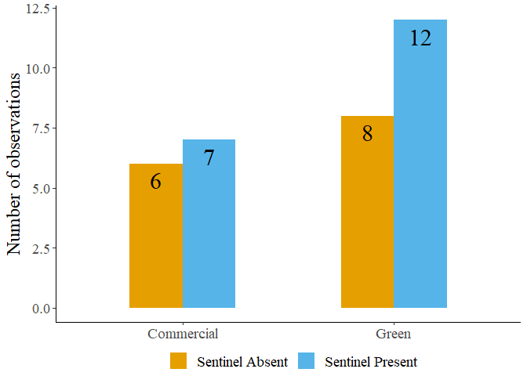

Figure S2: Sentinel presence in commercial and green areas.

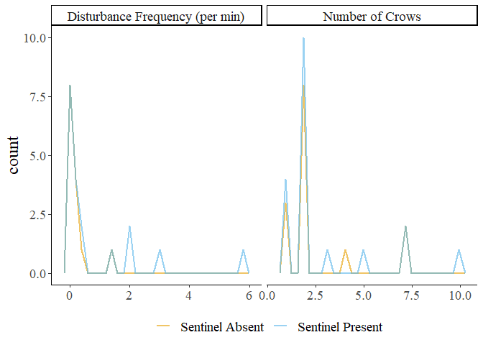

Figure S3: Frequency plots of observations in the presence and absence of a sentinel.

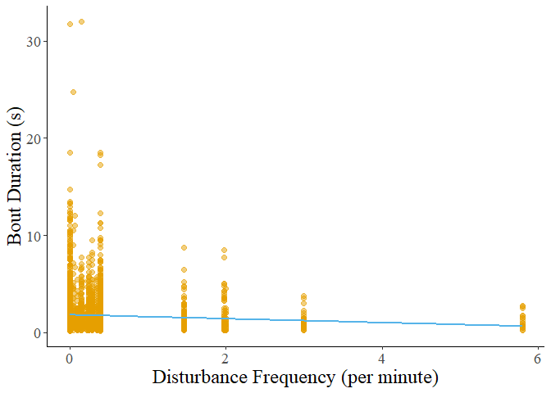

Figure S4: Decreasing bout duration of all behaviours in response to increasing disturbance frequency.

Table S3: Results of post hoc tests on foraging bout duration.

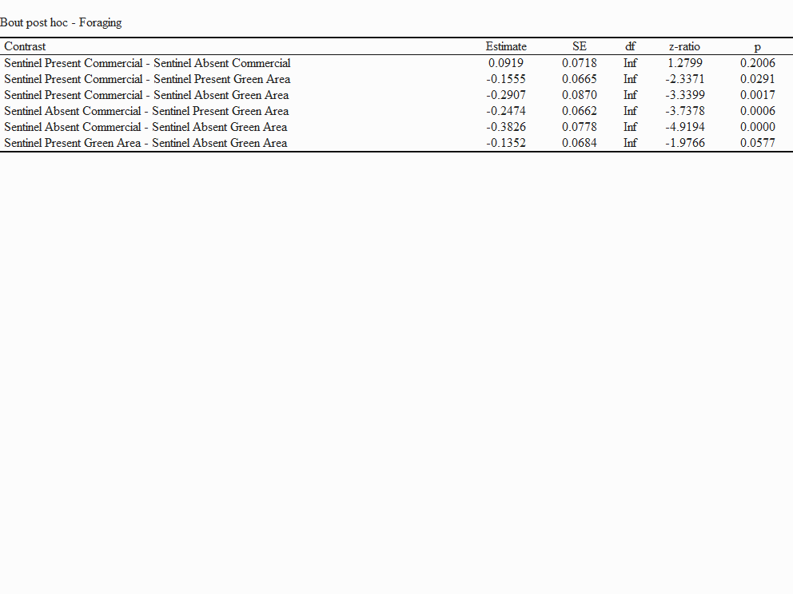

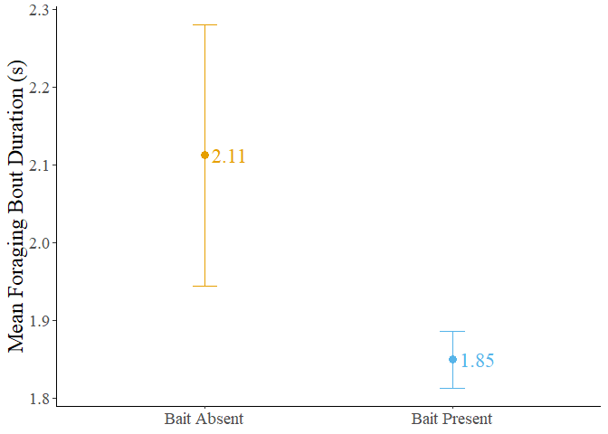

Figure S5: Mean bout duration in the presence and absence of bait. The dots represent the mean value, and the error bars represent the standard error.

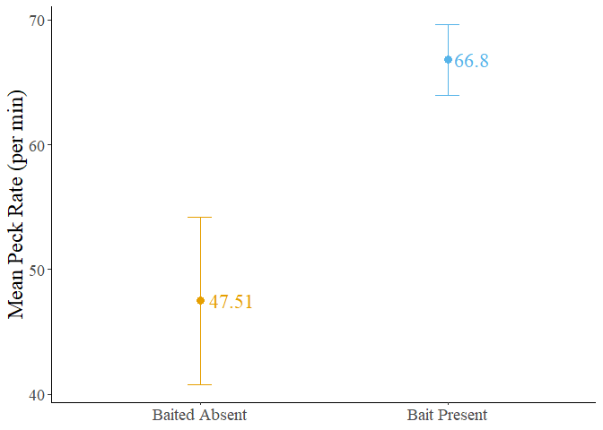

Figure S6: Mean forager peck rate in the presence and absence of bait. The dots represent the mean value, and the error bars represent the standard error.

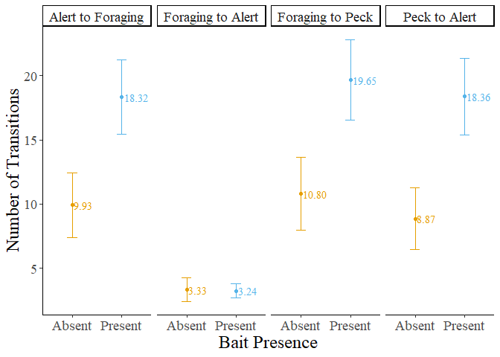

Figure S7: Number of transitions performed by foragers in the presence and absence of bait. The dots represent the mean value, and the error bars represent the standard error.

Table S4: Result of post hoc test performed on the number of transitions from foraging to alert behaviour.

